LEARNING AND TEACHING IN SOCIAL CONTEXTS, EDD

Graduate School of Education University at Buffalo

Updated March 2023
A handbook for students in the Learning and Teaching in Social Contexts (LTSC) Doctor of Education (EdD) program within the Department of Learning and Instruction (LAI).

2

TABLE OF CONTENTS
Click here for an overview presentation of the LTSC EdD program.

Mission & Identity 3
Guiding Principles 4
Signature Pedagogies 5
Sequence, Stages, & Experiences 6
Curriculum Map 7
Is the EdD right for me? 8
Application Process 9
Overview of Program Milestones 10
Prequalifying Paper 11
Qualifying Paper 12
Proposal Defense 13
Dissertation in Practice Defense 14
Dissertation in Practice: Overview 15
What is a Dissertation in Practice? 16
Theories of Change and Action 17
What is a Problem of Practice? 18
What is problematization? 19
Dissertation in Practice: Options 20
Dissertation in Practice: Outline Checklist 21
Dissertation in Practice: Evaluation Checklist 22
LTSC EdD Program Milestone Checklist & Forms 23
LTSC EdD Initial Course Plan Statement (ICPS) 24-26
Dissertation in Practice: The Model 27-38

MISSION & IDENTITY
''
Designed within an actionable, justice-focused framework, University at Buffalo's Doctor of Education in Learning and Teaching in Social Contexts blends contemporary theory and practice across synergistic learning experiences to produce the next generation of educational professionals dedicated
to addressing emergent and persistent problems of practice.
Who We Are ,,
- Change agents
- Stewards of practice
- Invested in our communities
- Improvement-focused inquirers & innovators

Who We Are Not
- We are not just solving problems.
- We are committed to fostering meaningful change to yield generative impacts in our local and global communities.

Our Students
- are leaders who collaborate across educational, academic, and community boundaries to identify, understand, design, and develop solutions to problems of practice.
- are leaders who establish and grow Intra- and inter-institutional capacity for continuous, evidence-based improvement.
- are leaders who advocate for and drive efforts to achieve educational equity.

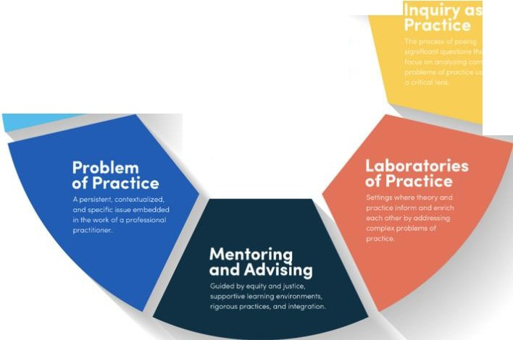OUR GUIDING PRINCIPLES

CPED GUIDING

PRINCIPLES
The University ot Buffalo is o member of theCarnegie Project
on the Educohon Doctorate (CPED). Our new EdD program ,s designed occord,ng to the followmg seven pr,nc,ples of rhoCPE0 Fromowork

OUR SIGNATURE PEDAGOGIES
To support students in their development and testing of theories of action, our program's signature pedagogies, or "the types of teaching that organize the fundamental ways in which future practitioners are educated for their new professions," include three dimensions: surface structure, deep structure, and implicit structure (Shulman, 2005, p. 52). While surface structures consist of concrete, operational acts of teaching andlearning, showing and demonstrating, and questioning and answering, deep structures reflect a set of assumptions about how to best impart a body of knowledge and know-how (Shulman, 2005). The third dimension, the implicit structure, includes ''a moral dimension that comprises a set of beliefs about professional attitudes, values, and dispositions" (Shulman, 2005, p. 55). Throughout the program, faculty will mentor doctoral students through coursework and applied research experiences using a signature pedagogy comprised of three components (Table 1).

Table 1 Three-Component Signature Pedagoav
Comconent | Scholar-Practitioner Develocment | Place in Proaram
Collaborative, Inquiry-Based Learning | - Inquiry as a teaching method seeks to develop inquirers and use curiosity as motivators leading to learning through personal engagement (Justice et al., 2009)  - Inquiry promotes the integration of theoretical and practical knowledge through reflection and dialogue about existing ideals of justice  and eauitv (Lvnn & Smith-Maddox, 2007) | - Stage 1: Coursework centering on a Problem of Practice (PoP)  - Interdisciplinary courses prepare students to define and address PoPs
Equity-Driven, • Equity-minded practitioners: (1) use data and Field-Based critical analysis to uncover patterns of Research inequity student outcomes; (2) are race­  conscious and consider the contemporary and historical context of exclusionary practices in America's institutions of higher education; (3) take personal and institutional responsibility for their students' outcomes and critically examine their own practices; (4) recognize and understand that inequalities are perpetuated and compounded by the interplay of institutional structures, policies, and practices that are within their control; (5)  are accountable to and take responsibility for closing student opportunity gaps (USC, 2020) |  | - Stage 2: Design and Research Methods for Improving Education  - In combination with Stage 1, methods courses enable students to develop practice­ based proposals and initiate opportunities for change in educational contexts
Generative, Transformative Leadership | - Transformative leadership begins with questions of justice and democracy; in practice, educational leaders create inclusive and equitable opportunities that yield generative impacts on learning environments (Shields, 2010)  - Transformative leadership links education and educational leadership with the wider social context within which it is embedded; therefore, transformative leadership and leadership for inclusive and socially just learning environments are inextricably related  (Shields 2010) | - Stage 3: Dissertation in Practice (DiP)  - In combination with Stages 1 and 2, students develop a DiP, or public statement of doctoral quality research, that demonstrates scholarly rigor and practitioner relevance

6
‘

YEAR 1 | YEAR 2 | YEAR 3
In Year 1, students participate in a set of learning experiences grounded in the Graduate School of Education’s identity: transformation of practice in educational leadership; school improvement as a matter of justice; and scholarship focused relentlessly on problems of practice. | In Year 2, students develop the capacity to formulate, communicate, and engage problems of practice in ways that (1) cross the boundaries of schools, the academy, and communities and (2) build intra- and inter-institutional capacity for research and development to yield generative impacts. | In Year 3, students render an account of the work and generative impacts against which the work will be assessed, evaluated, and improved. This account takes the form of a Dissertation in Practice which subsumes the learning activities and products of that learning throughout the program.

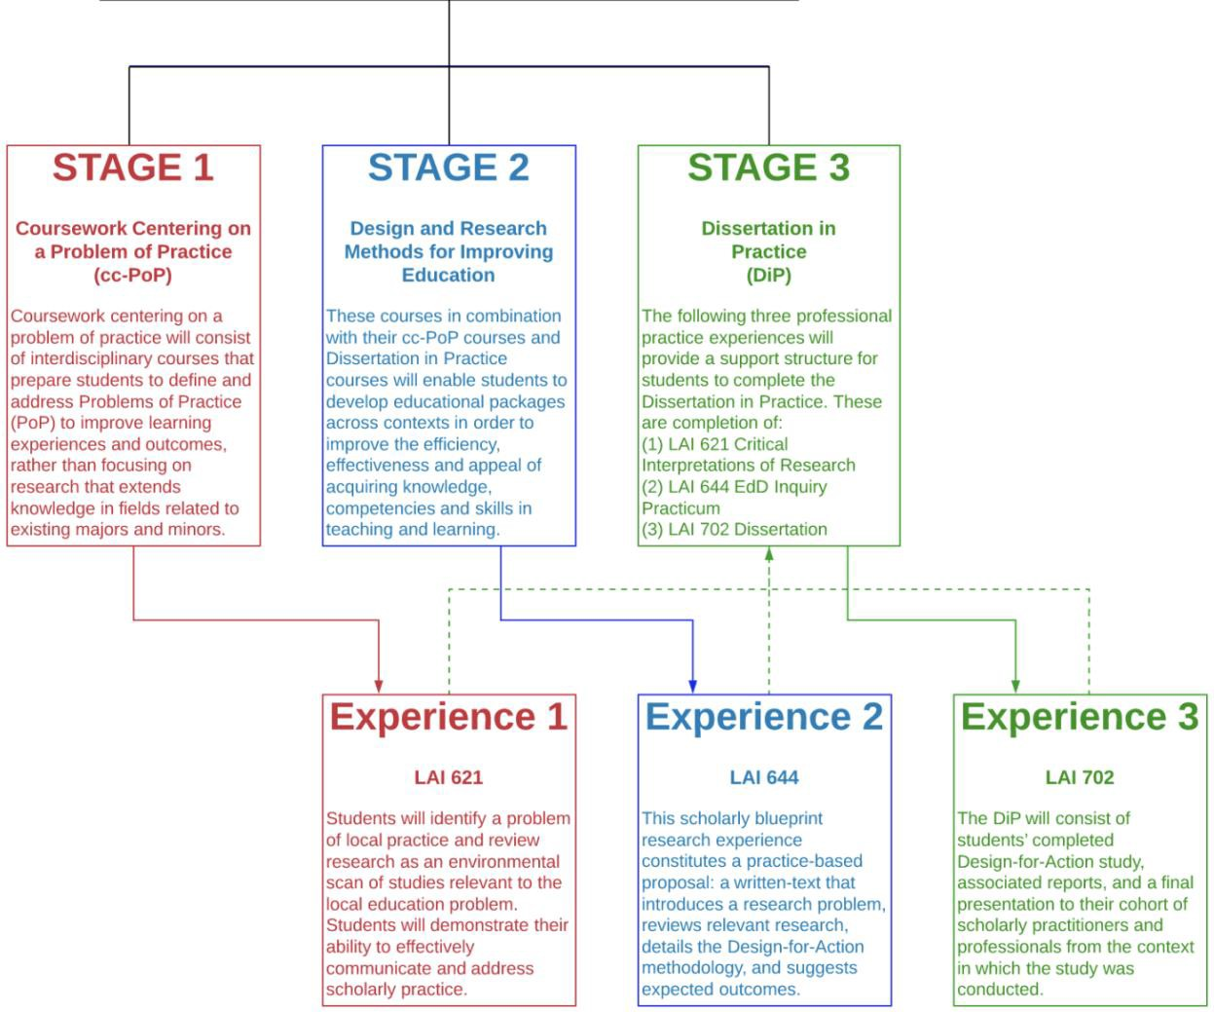

7

Click here for a downloadable copy of the curriculum map.

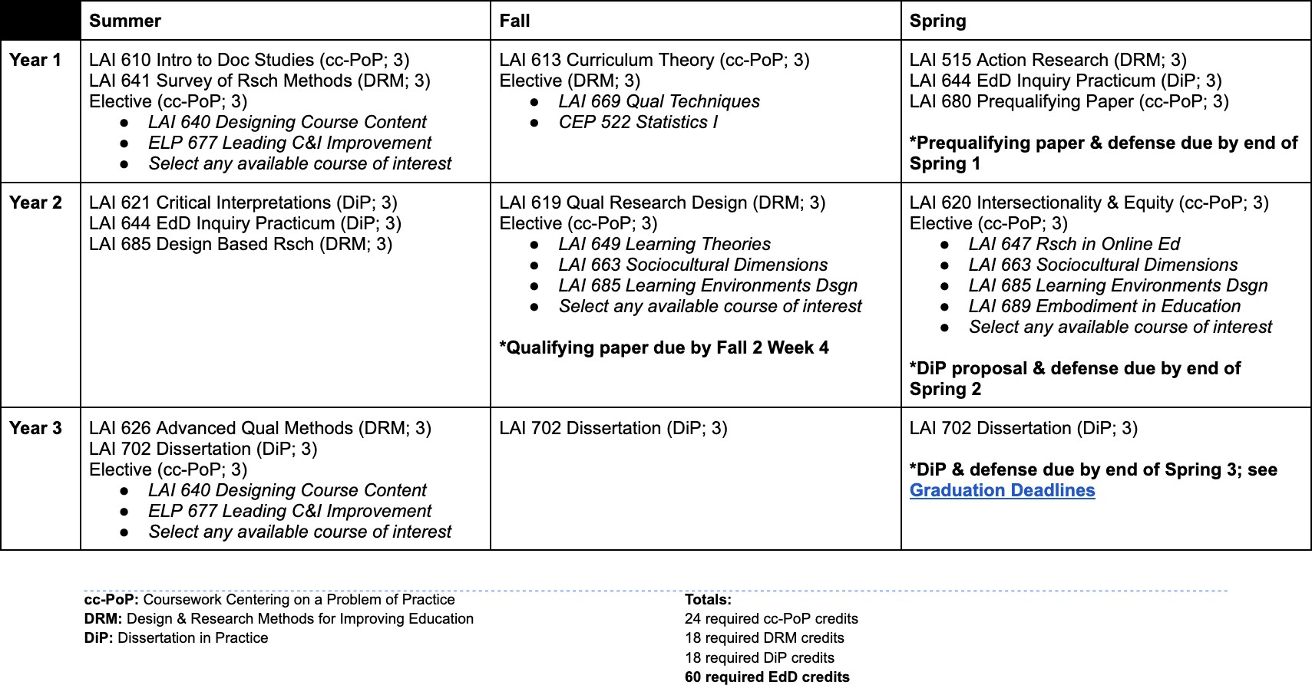

EdD | PhD
- Prepares candidates to be scholarly practitioners in their field, with a focus on applying what’s learned in the program to a career that will directly impact students, families and/or communities.  - Identifies new opportunities (or addresses age- old educational concerns) on a micro, rather than macro, level. Research and dissertation work will subsequently offer a practical application to the challenge(s) with real-life implementation or plans of execution.  - Admits students for part-time study only; the program structure allows completion in 3 full years of study. The program accommodates the needs of working professionals through specific, structured timelines and an online delivery model.  - Strengths:  - Applied, professional degree that teaches students how to solve problems and address challenges that education leaders face in a range of diverse contexts.  - Students seek solutions that are directly applicable to managing large, complex organizations.  - Students can hold full-time jobs.  - Since most EdD students are working professionals, classmates have the opportunity to learn from each other and build networks with people who may already be major players in their disciplines.  - Common jobs after graduation:  - Postsecondary education administrators  - Elementary and secondary school education administrators  - Top executives / senior-level professionals  - Instructional coordinators and coaches  - Teachers  - Staff developers  - Principals  - Program and curriculum directors  - Change agents  - Learning specialists  - University instructors | - Designed for candidates with clear research interests and proven capability to excel at rigorous coursework and in-depth research while immersed in full-time study.  - Focuses more on recognizing challenges in the greater learning climate and finding a solution to this general concern or obstacle. The program prepares candidates to conduct and publish ground-breaking research in their field and hold faculty positions at research institutions.  - Admits students for full-time study; the program can be completed in approximately 4 years when transferring credits from a master’s degree, or 5 years without.  - Strengths:  - Research intensive degree that produces scholars who spend much of their careers raising questions on best practices and outcomes for teaching and learning in K-12 and higher education settings.  - Students are trained to focus predominantly on publishing in top-tier journals and presenting papers at national conferences in pursuit of obtaining tenure-track faculty positions after graduation.  - Funded PhD students can focus full-time on coursework and research.  - Common jobs after graduation:  - Postsecondary teachers  - Academic researchers  - Consultants  - Analysts

Applicants must have a baccalaureate degree from an accredited institution. It is strongly preferred that applicants also have a master's degree.

If a prospective student aspires to join our intellectual community, the following materials must be submitted with the online application available through the Office of Graduate Admissions:

- Application fee: A $50 non-refundable application fee, submitted electronically through UB's ePayment system.

- Contact information for three professional references (1 academic preferred). Admissions will send a recommendation survey link to references; no letters required.

- Unofficial undergraduate and graduate transcripts from all colleges attended. (UB transcripts are automatically submitted for current UB students and alumni.) Upon admission to the program, official transcripts are required.

- Statement of Educational and Career Goals (500 word limit)
  - Your background: What key experiences have contributed to your commitment to work in the field of education or with education-related issues? Tell us how you think you are positioned to create change.
  - Your objectives for graduate study: What are your academic and professional goals and what knowledge, skills, and tools are you hoping to develop through enrollment in a graduate program? Why is graduate study the vehicle to drive the change(s) you wish to initiate?
  - Why UB GSE, and why this specific program? Why is enrollment at UB GSE and in the Department of Learning and Instruction critical in helping you achieve your goals?

- Problem of Practice Research Statement (250 word limit)
  - The Problem of Practice Research Statement should be a description of an issue:
    - What is the problem you have identified, and what information has drawn you to this specific issue?
    - The problem could be an issue you, your organization, or your field have struggled with for years, or it could be an innovation you wish to implement at your organization.
    - Focus your problem of practice as one that can create transformational change at your organization and be used for improvement or innovation in your field.
  - Sample problems of practice: increase the variety of teaching strategies used in classrooms; increase rigor in classrooms and support students in achieving higher levels of rigorous work; build a community of learners by focusing on productive student group work; examine the role of anti-bias education in classrooms and schools, and identify the relevant community issues that classes and schools must address; examine how teachers connect content to students’ prior knowledge and experiences, and support teachers’ capacity to enhance relevance in course materials.

Resume or Curriculum Vitae

- Optional: MAT or GRE test scores (verbal, quantitative, writing) taken in the last 5 years.

- Personal Interview Upon University Request: Applicants must make themselves available for online interviews with faculty.

When you submit your application, you will have the opportunity to answer the following question: Is there anything about your application that you would like the admissions committee to take into consideration?

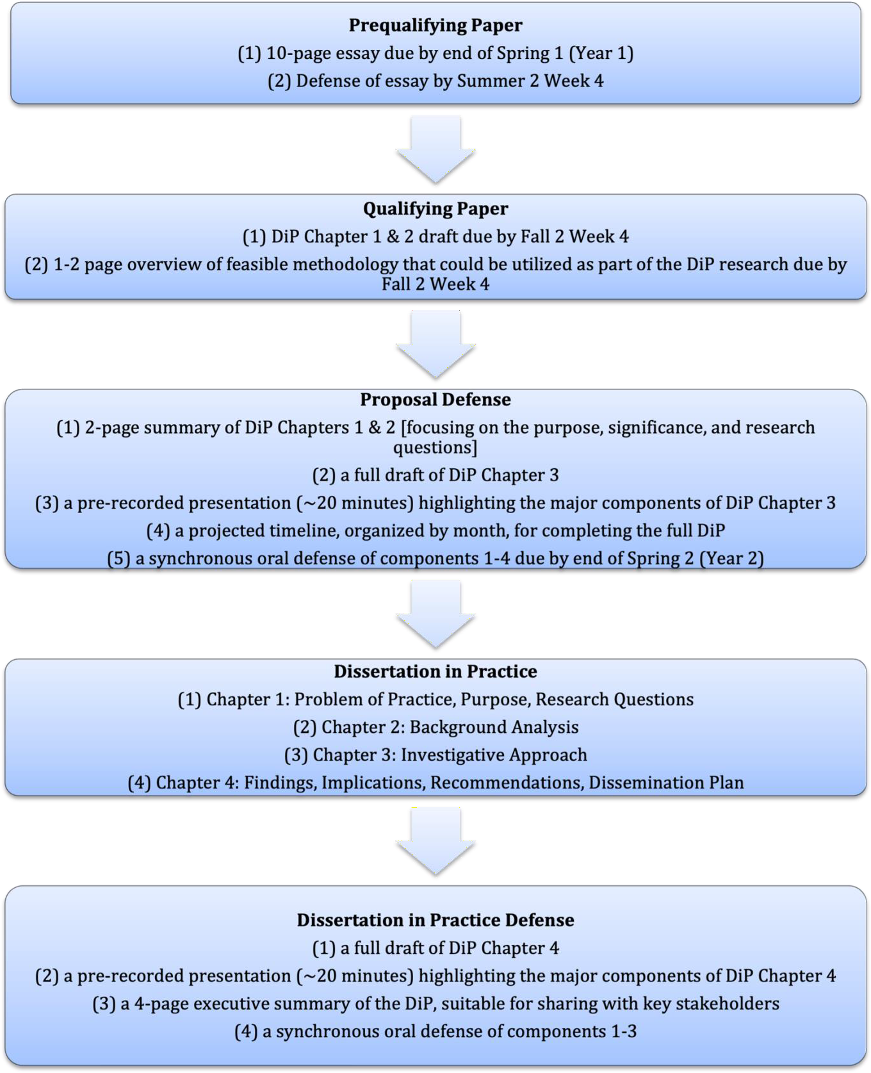

Click here for the Prequalifying Paper Form to be completed after the defense.

Every student who has been admitted to work toward the EdD in Learning and Teaching in Social Contexts (LTSC) must complete a departmentally administered prequalifying paper. This prequalification will be designed to appraise the student's ability to pursue the doctoral degree in the field and to facilitate advising in the development of the student's program of studies. Specific to the LTSC EdD program, the prequalification serves as a summative evaluation of the student’s work to date on identifying a Problem of Practice (PoP) that can be researched through their DiP.

Part 1: Content & Format

There are two components to the prequalifying paper:
- 10-page essay on the PoP that the study intends to study for their DiP due by end of Spring 1 (Year 1). Students will revise the draft in consultation with their advisor(s) and instructors prior to submitting the final version.
- Defense of the essay conducted synchronously with the committee due by Summer 2 Week 4.

Part 2: Evaluation

Advising faculty members (at least 2) will evaluate the extent to which the proposed PoP is adequately motivated, situated, and focused to support a feasible research design that could be completed during the length of the program. Faculty members will also evaluate the degree to which the essay adequately addresses the following elements:

- a formal statement of the PoP
- a brief discussion of the local context in which the PoP resides
- a brief discussion on the larger education policy and previous research context in which the PoP is situated
- a set of draft research questions
- a list of the local stakeholders related to the PoP

Students will either receive a pass or conditional continuance on their first attempt of the prequalification. A pass is awarded to students who adequately address all of the required elements, and whose PoP is appropriate and feasible to study. A conditional continuance is awarded to students who fail to adequately address several of the required elements of the essay and/or are unable to clearly articulate an appropriate and feasible PoP. If students receive a conditional continuance, they will have 4 weeks to rewrite their exam using the feedback provided by the advising committee. Students will then receive a pass or conditional continuance on their second attempt. Students who receive a conditional continuance on their second attempt will retake their prequalification in full in the following semester.
Students will receive either a pass or fail on their third attempt. If students receive a failing grade, they will not be able to continue in the program.

Part 3: Process

Students submit the 10-page essay by the end of the Spring 1 semester (i.e., at the end of Year 1). Students work with advising faculty members (at least 2) to schedule a Prequalifying Paper defense no later than the fourth week of the Summer 2 semester. The defense serves the purpose of providing feedback to the student, raising questions, and providing the student with the opportunity to pose additional questions to the committee.

Click here for the Qualifying Paper Form to be completed after committee review.

Every student who has been admitted to work toward a doctoral degree within the department must pass the qualifying paper in order to advance to doctoral candidacy. Per UB Graduate School policy, the qualifying paper is designed to test scholarly competence and knowledge and to afford the examiners the basis for constructive recommendations concerning the student's subsequent formal or informal study. Specific to the EdD program, the qualifying paper serves as an evaluation of whether a student has mastered the relevant subject area knowledge and is ready to pursue independent research on the DiP.

Part 1: Content & Format

The qualifying paper is a formal written document consisting of three sections:

- a full draft of DiP Chapter 1 due by Fall 2 Week 4
- a full draft of DiP Chapter 2 due by Fall 2 Week 4
- a 1-2 page overview of a feasible methodology that could be utilized as part of the DiP research due by Fall 2 Week 4. The methodological overview should also discuss the potential data source(s) that may be used, and the extent students will have access to these data.

Part 2: Evaluation

Faculty members (at least 2, continuing from the Prequalifying Paper defense) on the advising committee evaluate the degree to which sections 1 and 2 adequately address the required elements for Chapter 1 and 2 as specified in this document. For section 3, faculty members evaluate whether the proposed design is feasible and will answer the research questions.

Students will either receive a pass or fail on their first attempt of the qualification. A pass is awarded to students who adequately address all of the required elements. Students receiving a pass may be asked to do minor revisions to the document. A fail is awarded to students who fail to adequately address several of the required elements of the written document. If students receive a fail on the first attempt, they will have 4 weeks to rewrite their exam using the feedback provided by the advising team. Students will then receive a pass or fail on their second attempt. If students receive a failing grade on the second attempt, they will not be able to continue in the program.

Part 3: Process

Students submit the written component of the qualifying paper (i.e., full drafts of DiP Chapter 1 and 2) by Fall 2 Week 4. Advising faculty members (at least 2) will review the document and provide written feedback, including a pass/fail recommendation. Advising faculty members, in consultation with the EdD Director as needed, will render a pass/fail decision by the end of Fall 2 Week 6.
Results will be communicated to the student, with the EdD Director cc’d.

Click here for the DiP Proposal Form to be completed after the defense.

Prior to beginning their DiP research, EdD students must pass a proposal defense and acquire IRB approval. The proposal defense is a major milestone and will be evaluated by the full DiP committee. Every student who has been admitted to work toward a doctoral degree within the department must pass the proposal defense before engaging in dissertation research. Specific to the EdD program, the proposal defense serves an evaluation of whether the student has designed an appropriate research study that can be effectively executed in pursuit of the EdD.

Part 1: Content & Format

There are five components to the proposal defense:

- a 2-page summary of DiP Chapters 1 and 2 (focusing on the purpose, significance, and research questions associated with the study) due by end of Spring 2 (Year 2)
- a full draft of DiP Chapter 3 due by end of Spring 2 (Year 2)
- a pre-recorded presentation (~20 minutes) highlighting the major components of DiP Chapter 3

due by end of Spring 2 (Year 2)
- a projected timeline, organized by month, for completing the full DiP due by end of Spring 2 (Year 2)
- a synchronous oral defense of components 1-4 due by end of Spring 2 (Year 2) Part 2: Evaluation
Faculty members on the full DiP committee (at least 3) will evaluate the degree to which the components (particularly component 2), adequately address the required components specified above. DiP committee members will review components 1-4 prior to meeting synchronously with the student to conduct component 5.

Students will either receive a pass on their first attempt of the proposal defense or will be required to revise and re-defend at a later date. The full DiP committee, led by the primary advisor, has final discretion on this matter and the associated timeline for any re-defense. Students receiving a pass may still be required to revise DiP chapter three based on the committee’s feedback. Students will not be able to begin conducting DiP research until a passing grade is received on the proposal defense, and IRB approval has been obtained.

Part 3: Process

Students will submit final versions of components 1-4 by the end of Spring 2 (Year 2). The full DiP committee (at least 3 faculty members) will review these components in advance of a synchronous defense that will take place towards the end of Spring 2 (Year 2). As noted, this is only a projected timeline. Students will advance to the proposal defense only when the primary advisor has determined the student has submitted a satisfactory proposal. Upon successful completion of the proposal defense, students should apply for IRB approval through the UB Office of Human Subjects.

Click here for the DiP Form (i.e., M-Form) to be completed after the defense.

The final exam stage of the EdD program is the Dissertation in Practice defense.

Part 1: Content & Format

There are four components to the DiP defense:

- a full draft of DiP Chapter 4
- a pre-recorded presentation (~20 minutes) highlighting the major components of DiP Chapter 4
- a 4-page executive summary of the DiP, suitable for sharing with key stakeholders
- a synchronous oral defense of components 1-3

Part 2: Evaluation

The full DiP committee (at least 3, continuing from the proposal defense) will receive components 1-3 at least 2 weeks before the synchronous DiP defense. During the defense, the full DiP committee will determine the extent to which students have adequately met the requirements as specified in this document.

Students will either receive a pass on their first attempt of the DiP defense or will be required to revise and re-defend at a later date. The full DiP committee, led by the primary advisor, has final discretion on this matter and the associated timeline for any re-defense. Students receiving a pass may still be required to revise the DiP based on the committee’s feedback.

Part 3: Process

The timeline for the DiP defense is determined by the student and primary advisor; other faculty members of the DiP committee may be consulted about the timeline. Students are advised to adhere to any deadlines specified by the Graduate School, including deadlines to submit the pre-defense DiP draft for initial formatting review, and the post-defense, fully revised DiP for final review. Students should review The Graduate School’s Doctoral Student Graduation Requirements and Deadlines.

A doctoral dissertation in practice must be completed on a Problem of Practice relevant to the area of major. To be acceptable it must be an achievement in original research constituting a significant contribution to knowledge and represent a substantial scholarly effort on the part of the student.

The dissertation in practice represents a public statement of doctoral quality research. Its designation as a dissertation in practice report emphasizes its practitioner-based research focus. Unlike a traditional Ph.D. dissertation that is often written for a restricted community of scholars, the DiP is directed at a wider audience that is focused on practitioners. In other words, your findings will have real world applicability for professional working in varied educational settings. As a scholar practitioner, you will produce a report that demonstrates both scholarly rigor and practitioner relevance. Therefore, the DiP adheres to specific research standards and protocols that ensure the integrity of your work and the reputation of University at Buffalo.

Components of the Dissertation in Practice:

Chapter 1
- Problem of Practice
- Purpose
- Research Questions

Chapter 2

- Background Analysis

Chapter
3

- Investigative Approach

Chapter
4
- Findings
- Implications
- Recommendations
- Dissemination Plan

Focused by a lens of justice on a Problem of Practice, a Dissertation in Practice is the scholarship that yields generative impacts on the practice of educational leadership and the aims of educational improvement.

Unlike a traditional Ph.D. dissertation that is often written for a restricted community of scholars, the DiP is directed at a wider audience, one that is focused on practitioners. In other words, your findings will have real-world applicability for professional working in varied educational settings.

As a scholar practitioner, you will produce a report that demonstrates both scholarly rigor and practitioner relevance. Therefore, the DiP adheres to specific research standards and protocols that ensure the integrity of your work and the reputation of University at Buffalo.

Click here to access CPED’s Dissertation in Practice resource center and view sample DiPs.

What is a Theory of Change?
A Theory of Change has been defined as the hypothesis about the way that a program brings about its effects (Scriven, 1991). It causally links inputs and activities to a chain of intended, observable outcomes (Rogers, 2008). It helps the organization identify the assumptions that underlie the hypothesis and track the intermediate outcomes that the organization expects to see as it implements its plan toward achieving its long-term goal (Weiss, 1995).

What is a Theory of Action?
A theory of action can be thought of as a story line that makes a vision and a strategy concrete. It provides a line of narrative that leads people through the daily complexity and distractions that compete with the main work of the instructional core. The theory of action provides a map that carries the vision through the organization. It provides a way of testing the assumptions and suppositions of the vision against the unfolding realities of the work in actual organizations with actual people. -UC Davis

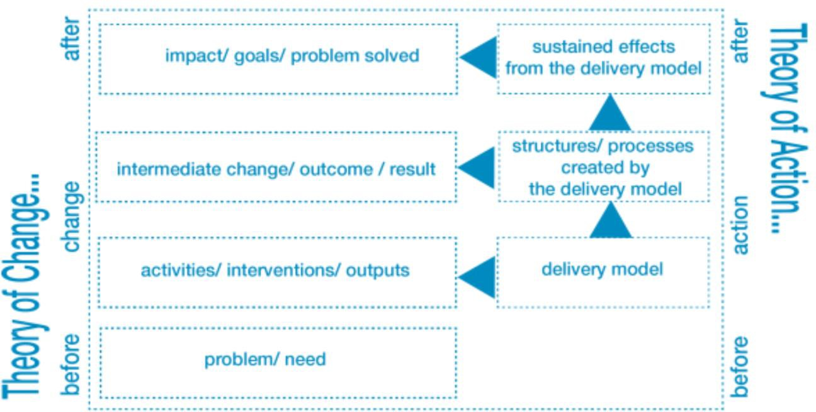

A Problem of Practice is directly observable in its local setting and is malleable and actionable.
There should be some form of evidence to demonstrate that the Problem of Practice exists, and there should be a plausible way of addressing this problem based on existing research.

Defining a Problem of Practice can often be as straightforward as demonstrating a disparity in educational access or outcomes for a group of students, educators, or others involved in educational settings.

Depending on the context, defining the Problem of Practice may be more nuanced; however, every Dissertation in Practice should contain a clear Problem of Practice statement.

Click here for UC Davis’ guide to developing a PoP and applying a Theory of Action.

To address our Problem of Practice…
In the short-
term, we need to...
We will do this
by...
So that in the
medium term...
Which will lead
to...
So that in the
long term...

“According to Crotty (1998), problematization involves a process of de-familiarizing terms, opinions, concepts, and ideologies which people have come to accept as shared knowledge or ‘common sense’. As such, problematization can be viewed as a critical activity aimed at unpicking and unpacking the things that are commonly accepted to encourage new viewpoints, perspectives, ideas, and actions to emerge. Through a problematization process, therefore, one can generate new insights which offer opportunities to not only advance understanding of the nature of different phenomena, but can provide the ability to comprehend old and sometimes entrenched ‘challenges’ with a fresh set of eyes”
(Reeves, 2010).

Reeves, S. The need to problematize interprofessional education and practice activities. (2010). Journal of Interprofessional Care, 24(4), 333-335. doi:10.3109/13561820.2010.492748

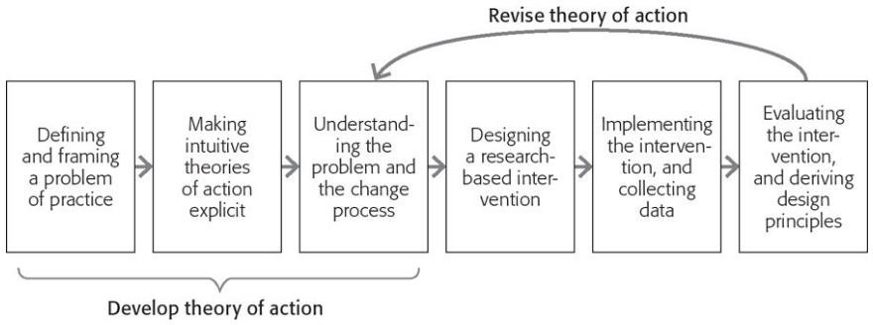

Adapted from Florida State University’s Dissertation in Practice

At its core, the Dissertation in Practice is original research that investigates a Problem of Practice specific to its local educational context by utilizing one of three types of studies:

- An exploration study to better understand the factors contributing to a Problem of Practice and offer potential solutions to address them,

- An intervention/innovation study to design, implement, and analyze an improvement initiative designed to address a Problem of Practice, or

- An outcomes study to analyze and interpret the outcomes of existing programs or policies designed to address a Problem of Practice.

Additional studies may be considered in consultation with the supervisory committee. Regardless of the type of study, the Dissertation in Practice consists of four chapters:
  - Problem of Practice, Purpose of the Study, and Research Questions

  - Background Analysis

  - Investigative Approach

  - Findings, Implications, Recommendations, and Dissemination Plan

This resource is a guide; criteria specific to your DiP should be discussed in consultation with your advisor.

Criteria | Page # | Complete?
CHAPTER 1: PoP, Purpose, Research Questions

*Note that a draft of Chapter 1 is considered part of the Qualifying Paper due Fall 2 Week 4
Problem of Practice Statement
Purpose, Research Questions, & Study Design Overview
Study Site Overview & Feasibility
Significance
Conclusion
CHAPTER 2: Background Analysis

*Note that a draft of Chapter 2 is considered part of the Qualifying Paper due Fall 2 Week 4
Introduction
Orientation within the Larger Educational Landscape
Previous Studies on <PoP topic>
Description of the Local Context
Summary and Contributions of this DiP
CHAPTER 3: Investigative Approach

*Note that a draft of Chapter 3 is considered the Proposal Defense due end of Year 2 (Spring)
Introduction and Study Type Description/Rationale
Research Design
Limitations
Summary
CHAPTER 4: Findings, Implications, Recommendations, Dissemination Plan

*Note that a draft of Chapter 4 is considered the full DiP; determine Year 3 defense date
Study Summary
Findings
Implications
Recommendations
Conclusion
Dissemination Plan

This resource is a guide; criteria specific to your DiP should be discussed in consultation with your advisor.
Criteria | Page # | Line #
Have you provided an introduction for the DiP that…
prepares readers for and encourages engagement in the discourse?
uses a lens of social justice to explicate a PoP and design for action?
informs the reader how argumentation will guide the discourse?
introduces the guiding claims?
situates claims in the context of practice?
provides a roadmap for how the arguments will be organized?
Have you argued compellingly that the PoP…
introduces a high leverage problem likely to yield improvement?
defines the PoP through the process of systematic inquiry?
is informed by critical review of data across community boundaries?
is informed by critical review of data through multi-disciplinary lenses?
is informed by critical social theories and epistemological frameworks?
is situated in relation to institutional networks of power?
recognizes inequitable structures of power between communities?
addresses one or more cultural dimensions of power?
Have you argued compellingly that the design for action…
is situated within relevant theoretical and empirical antecedents?
fits the context in which it will be implemented?
seeks to challenge and transform status quo practices in education?
is informed, understood, and supported by design stakeholders?
yields or will yield assessment data that test the claims of the design?
includes the processes by which data are rendered into evidence?
places value ethically and in service of learners?
provides for continuous cycles of improvement?
is or will be usable in the field?
will serve as the basis for effective advocacy for educational equity?
Have you argued compellingly that the generative impacts…
can be measured?
can leverage change in the practice of educational leadership?
support the establishment of networked improvement communities?
addresses a moral, ethical, and political vision for socially just schools?
includes products that serve leaders and marginalized communities?
account for the aims of educational improvement?

Year & Semesters | EdD Milestones & Procedures | Check for Completion
Year 1  (Summer 1, Fall 1, Spring 1) | Student completes ~24 credits.
 | Student forms a committee comprised of two total faculty members with graduate faculty status to serve the Prequalifying Paper and Qualifying Paper milestones.
 | Student completes the Prequalifying Paper by the end of Spring 1, which includes a defense to be completed by Summer 2 Week 4.
 | Student completes and submits the EdD ICPS Form and Prequalifying Paper Form to the EdD Director.
Year 2  (Summer 2, Fall 2, Spring 2) | Student completes an additional ~21 credits.
 | Student completes the Qualifying Paper by Fall 2 Week 4.
 | Student sends the Qualifying Paper Form to the EdD Director.
 | Student forms a DiP committee comprised of three total faculty members with graduate faculty status to serve the DiP Proposal and Final DiP milestones.
Year 3  (Summer 3, Fall 3, Spring 3) | Student completes an additional ~15 credits.
 | Student completes the DiP Proposal by the end of Spring 2, which includes a defense to be completed by the end of Spring 2.
 | Student completes and sends the DiP Proposal Form to the EdD Director.
 | Student continues working on the final DiP, which is to be completed and defended by the end of Spring 3.
 | Student completes and sends the M-Form and updated/finalized ICPS Form to the EdD Director.
 | Student completes remaining items on The Graduate School’s Doctoral Student Graduation Requirements and Deadlines.

Department of Learning and Instruction Initial Course Plan Statement (ICPS)

This form is for students in the Learning and Teaching in Social Contexts EdD program.

Student Information

Name

Person #

Address

Phone

Email

Program Milestone Information

Semester of Acceptance Summer Fall Spring

Prequalifying Paper Date Semester Date (MM/DD/YY)

Qualifying Paper Date Semester Date (MM/DD/YY)

Proposal Defense Date Semester Date (MM/DD/YY)

DiP Defense Date Semester Date (MM/DD/YY)

Program Credit Hours Information

Stage & Required Credits | # of Credits Based on Information provided on p. 2
Coursework Centering on a Problem of Practice (cc-PoP)
24 credits required
- LAI 613 Curriculum Theory (3 credits)
- 21 elective credits selected in consultation with Advisor
Design and Research Methods for Improving Education (DRM)
18 credits required
- LAI 515 Action Research (3 credits)
- 15 elective credits selected in consultation with Advisor
Dissertation in Practice (DiP)
18 credits required
- LAI 621 Critical Interpretations of Research (3 credits)
- LAI 644 EdD Inquiry Practicum (6 credits)
- LAI 702 Dissertation (9 credits)
Total Credits
60 credits required

List Doctoral Courses to be Counted Toward the 60-Hour Minimum EdD Degree

Coursework Centering on a Problem of Practice (cc-PoP)
24 credits required
Dept. Abbreviation & Course Number | Course Title | Credit Hours | Grade | Instructor | Semester & Year to be  Registered
1. LAI 613 | Curriculum Theory | 3
2.
3.
4.
5.
6.
7.
8.
9.
10.
TOTAL CREDITS IN CC-POP
Design and Research Methods for Improving Education (DRM)
18 credits required
Dept. Abbreviation & Course Number | Course Title | Credit Hours | Grade | Instructor | Semester & Year to be Registered
1. LAI 515 | Action Research | 3
2.
3.
4.
5.
6.
7.
8.
9.
10.
TOTAL CREDITS IN DRM
Dissertation in Practice (DiP)
18 credits required
Dept. Abbreviation & Course Number | Course Title | Credit Hours | Grade | Instructor | Semester & Year to be Registered
1. LAI 621 | Critical Interpretations of Research | 3
2.
3.
4.
5.
6.
7.
8.
9.
10.
TOTAL CREDITS IN DiP

Signatures

Student’s Name (Printed) Student’s Name (Signature) Date

Advisor’s Name (Printed) Advisor’s Name (Signature) Date

Program Director’s Name (Printed) Student’s Name (Signature) Date

CHAPTER 1 - OVERVIEW
Problem of Practice Statement, Purpose, and Research Questions
The purpose of chapter one is twofold. First, the chapter narrows the dissertation’s focus from a larger problem to illuminate the specific problem of practice that the candidate seeks to improve through evidence-based improvement. Problems of practice reside in complex contexts with multiple, uncertain causes and various interpretations determined by the beliefs and assumptions of a variety of stakeholders. The second purpose is to persuade others that a problem exists within the candidate’s sphere of influence. In mounting this persuasive argument, the candidate must describe the current gap between the existing state and the preferred or goal state within the candidate’s organizational context.

The chapter should answer the overall question: What is the specific problem of practice, why does it need to be addressed, and what is the candidate’s position on the problem?
Chapter 1 Overview | Chapter 1 Purpose | Chapter 1 Critical Questions
- Social, cultural and historical perspectives on the problem  - Local contextual perspectives on the problem  - The candidate’s leadership perspectives on the problem  - The specific problem of practice within the candidate’s sphere of influence that this DiP addresses  - Central research questions | - To frame the larger conceptual problem and introduce your audience to a) this problem exists and b) there are important equity and justice implications if we do not do something to improve the situation.  - To narrow from the larger conceptual problem to how this problem presents itself in your local context. It is important to provide the audience with  a) rich description of your local setting and b) the specific equity and justice implications for the people that your organization serves.  - To narrow further from the local perspective to your area of expertise to lead improvement.  - To identify the targeted practices of your improvement efforts. This description must “connect the dots” to show how you have narrowed the larger problem to a tightly focused problem of practice.  - To present the research questions that will guide your inquiry into how to | - Why is the problem important to the education of the people your organization serves?  - What are the perspectives on the problem across relevant stakeholders?  - What attempts have been made to address the problem within your organization?  - Have others in your community tried to address the problem?  - What practices have you observed within your local context?  - What previous and current experiences lead you to your framing of the specific problem of practice?  - What specific practices are the foci of your study and why?  - How should the gap between the current state of practice and the preferred state of practice be defined?  - What social justice issues are directly related to the current set of practices?  - What political, policy, and/or public relations issues are connected to the  current practices?

 |  | improve the specific problem of practice. Problems in organizations are not reducible to a single proposition about causes and consequences. A core problem of practice necessitates multiple lines of inquiry, examinations of various causes and consequences, and identification alternative solutions and designs for improvement. The research question or questions follow from that focused problem of practice are presented at the end of Chapter 1. The tight focus and research questions that emanate from that focus frame the actionable knowledge examined in  Chapter 2. | - What issues might arise during an improvement effort and how might they be handled?
CHAPTER 1 – DEVELOPING AN OUTLINE
Problem of Practice Statement, Purpose, and Research Questions
Problem of Practice Statement | Establishing an appropriate PoP statement that will support feasible and rigorous research is an important first step towards the DiP. PoP statements should be series of four paragraphs that delineate the broad problem in society, some evidence of this broad problem within the research literature, and how this problem manifests itself in the candidate’s context. Guiding questions:  - What are the urgent problems in our organization?  - What are our spheres of influence within the organization, and which problems are within that sphere?  - Which problems can be addressed within a specified time frame of a design development study and within the resource and capacity limitations of our organization?  - Which problems are strategically connected to the goals of the larger organization or administrative unit (such as a school district)?  - Which particular practices happening in the organization are indicators of this problem?  More explicitly the following paragraph guide can be used to state the PoP (note: this paragraph guide is adapted and expanded from Johns Hopkins University and Florida State University):  Paragraph 1: State the broad problem in society. You may want to begin with an introductory or explanatory sentence.
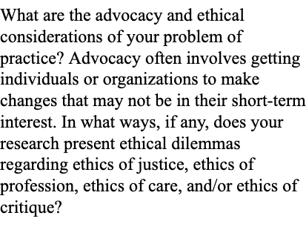

Paragraph 2: Provide at least three evidential statements of the problem including citations. These are statements that provide evidence that the problem exists in various forms.

Paragraph 3: State how this big problem manifests itself in your professional context.

Paragraph 4: Discuss the purpose of the study, its significance, and how it addresses the problem of practice.

Example: Achievement Disparities among Traditionally Underserved Students

Paragraph 1: A snapshot of the American educational landscape in 2011 reflects a strikingly similar portrait of the K-12 environment 30 years ago. From A Nation at Risk (Gardner, 1983) to the No Child Left Behind (NCLB, Act of 2001), the state of education remains distressed, particularly for traditionally underserved students.

Paragraph 2: Stagnant academic performance persists among low-socioeconomic and minority students (Lee, 2006), and National Assessment Education Statistics data analyses delineate how achievement gaps have remained relatively stable between different groups of students (Lee, 2006; Rampey, Dion, & Donahue, 2009). High school dropout rates have risen in some groups of traditionally underserved populations (Balfanz & Letgers, 2006; Barton, 2000; Greene, 2002; Greene & Winters, 2005; Sum & Harrington, 2003, Swanson & Chaplin, 2003). Further, school failures within our most needy districts in urban and rural locales leave underserved populations without access to educational resources. NCLB (2001) was passed to ameliorate the persistent performance differences, yet the result in many places has been to widen already existing gaps in achievement and access to educational resources.

Paragraph 3: The persistent low levels of achievement and unequal access continue to frustrate practitioners and researchers. In Green High School (GHS), student success records mirror the US national patterns: traditionally underserved minority students graduate at lower rates than their privileged counterparts, gaps exist between many groups, fewer of these students are represented in AP courses, resources have been withdrawn from the school as a result of NCLB policies, and dropout rates at GHS have not abated (CITATION to school records).

Paragraph 4: The purpose of this Dissertation in Practice (DiP) is examine the factors that contribute to the low levels of achievement at GHS for traditionally underserved minority students. This exploratory study will utilize existing student records as well as data obtained via interviews with students and teachers to help shed important light on the factors driving the low levels of academic achievement. The ultimate goal of this study is to offer a set of specific policy recommendations that may improve the achievement of traditionally underserved minority students at GHS. The findings of this study stand to make an important contribution to the future of these students at GHS and will be of great benefit to several key stakeholders: teachers, administrators, as well as the students themselves and their families.

Explanation: In this example, the POP statement remains broad and focused on the outcome problem: achievement disparities among traditional underserved students. This statement provides evidence that the problem exists: NAEP data, graduation rates, drop-out rates, school failures, and diminished access to
educational resources. Lastly, it describes how the problem within the context of professional practice reflects the national problem.
Purpose, Research Questions, and Study Design Overview | The purpose statement of a Dissertation in Practice explains why a researcher’s study will be conducted and what the study will accomplish. It guides the research, describes the expected outcomes, and explains the means for collecting data. If we think of the problem statement as the heart of the study, then we can think of the purpose statement as the brains of the study. The purpose statement tells your reader what the primary goal of the research is/was. In addition to stating the objective of the research, the purpose statement informs the reader of: the method of research, population under investigation, the setting, and includes the phenomena or variables being studied.  - Example: The purpose of this qualitative correlational study was to determine the relationship between teacher job satisfaction and the teacher-perceived leadership traits of principals within public schools (K-12) in the coastal region of Virginia. The significance of the relationship is that it may inform an understanding of how teacher leadership influences teacher retention, which has been correlated to satisfaction (Johnson, 2004). The study used validated and reliable attitudinal measures to assess the variables under investigation.  Proper research questions should be:  - Focused on a single problem or issue  - Researchable using primary and/or secondary sources  - Feasible to answer within the timeframe and practical constraints  - Specific enough to answer thoroughly  - Relevant to your field of study and the context in which you identify the PoP
Study Site  Overview and Feasibility | This section should contain sufficient detail about your local context so as to allow the reader to understand how the  study focus is appropriate for the local context. This section should also include a note about the feasibility of the study.
Significance | This section should discuss the importance of the study in relation to the PoP and the stakeholders who will benefit from learning its findings.
Conclusion | This section should summarize the purpose and investigative approach of the DiP. This section should also contain a roadmap for the reader about the following sections (note: this will likely need to be revised once the full DiP is completed).
CHAPTER 2 - OVERVIEW
Background Analysis (Review of Literature and Knowledge for Action)
The background analysis, or review of literature and knowledge for action, moves away from the theoretical and towards a conceptual
framework. It provides the reader with sufficient background information to understand how the PoP is situated within the broader educational landscape as well as detailed information on the local context/study site where the PoP is observed. The EdD has a particular

focus on practice; for this reason, Chapter 2 is not termed a “literature review,” but a “background analysis” that while drawing from existing literature, also focuses the reader on the local context. One way to think about Chapter 2 is as a funnel, or inverted pyramid. The Chapter begins broadly by orienting the reader to how the PoP being studied is situated within the larger educational landscape, often through a series of facts. From there, the chapter continues to sharpen its focus by presenting the reader with information related to previous studies that have investigated similar issues as the PoP, providing more details about the PoP itself and the local context in which it is observed, and concluding with brief summary and a statement on the contribution of the DiP. How does the literature frame your problem of practice and suggest ideas for how to address it? This is a process of naming and framing what you’re trying to study.
- Demonstrates knowledge of the topic as it relates to the PoP
- Reveals influential researchers and practitioners who have studied the topic
- Identifies why the PoP is an issue with support from prior literature
- Moves away from a broad review of the literature towards a focus on what’s going on in the researcher’s local context as it relates
to the broader literature
- Demonstrates acquisition of the PoP vocabulary
- Defends the PoP, why it’s an issue, and identifies contextual factors that influence it

At the broadest level, Chapter 2 can be understood as a rationale/justification for the study. In many ways, Chapter 2 elaborates on ideas originally introduced in Chapter 1. The chapter should answer the overall question: What should we do to improve the situation relative to the problem of practice?
Chapter 2 Overview | Chapter 2 Purpose | Chapter 2 Critical Questions
- Review of the educational research literature: theoretical sources  - Review of the educational research literature: empirical sources  - Data from relevant stakeholders  - Extant data from the organization  - Summary | - To review the specific theories that provide a conceptual basis for understanding, analyzing, and designing ways to investigate and improve specific educational practices operating within context and social systems of your problem of practice. You might be able to do this by rooting your study in one theory or by connecting several important theories to form a theoretical framework.  - To review the important research studies most closely to your problem of practice. Empirical research is based on observed and measured phenomena and derives knowledge from actual experience rather than from theory or | - How does theory connect to your problem of practice?  - How do the theoretical sources justify the research question(s)?  - How does theory guide and inform improvement efforts and improved practices?  - How does theory support the arguments you make for improvement efforts?  - How does theory justify the need for improvement and the specific practices that will make up your improvement?  - How does theory help you evaluate (monitor and adjust) your leadership impact on the problem of practice?  - What is the validity and reliability of the study?

 | belief. These studies share the following key characteristics. They:  - Answer specific research questions.  - Define the population, behavior, or phenomena being studied.  - Describe the process used to study the population or phenomena, including selection criteria, controls, and instruments (such as surveys).  - Appear in research journals and usually have the following four components: 1) Literature Review,  2) Methods, 3) Findings/Results, and  4) Discussion/Conclusions.  - To present existing data from relevant stakeholders that relate to and explain the current state of the problem of practice and perspectives on the gap between the current and ideal state.  - To present extant data that inform, explain, and justify the problem of practice and the leadership initiative designed to improve it.  - To summarize the connections among the sources of actionable knowledge reviewed. | - What specific theory or theories does the study apply?  - How do the empirical sources justify the research question(s)?  - Are there studies that point to alternative approaches to the specific problem of practice?  - How does the empirical study relate to your problem of practice?  - How do the results of the study support your argument for the improvement effort?  - How does the study justify the specific practices that will be part of your improvement effort?  - What are the perspectives, beliefs, levels of expertise that are supported by existing stakeholder data?  - What are the challenges and opportunities that stakeholders that must be considered based on existing stakeholder data?  - Is there documented evidence from your organization that informs your problem of practice?  - Is there documented evidence that shows the impact of past or current initiatives designed to address the problem?  - How do the extant data sources justify the research question(s)?  - How can you summarize the ways that the sources of actionable knowledge that you reviewed warrant your claims about the specific nature of the problem  of practice?

- How can you summarize the way the sources reviewed justify the problem’s significance to the organization?
- How do the sources reviewed work together to point toward a reasoned approach to addressing the specific
problem of practice?
CHAPTER 2 – DEVELOPING AN OUTLINE
Background Analysis (Review of Literature and Knowledge for Action)
Introduction | This section provides context and sets the dimensions of the PoP. This is an overview of the chapter and should provide a roadmap for the rationale/justification for the study. The study rationale is built by laying out a series of claims in a thoughtful way. This can include claims of concept, fact, worth, policy, or interpretation. The candidate should remember that each claim made needs to be backed by evidence. The evidence presented consists of individual pieces of data, which are the individual citations. This introduction lays out the candidate’s argument and offers a  general statement regarding how the chapter is structured and is relevant to the candidate’s research topic/questions.
Orientation within the Larger  Educational Landscape | This section should elaborate on the PoP statement. Specifically, the candidate should state the problem in society and provide evidence statements of how the selected PoP exists in various forms and at different levels within the educational landscape.
Previous Studies on <PoP Topic> | This section should present findings from existing studies that are related to the PoP. What have other studies found that have investigated a similar PoP? What are the shortcomings of existing studies? How might the candidate improve upon these studies as they investigate their specific PoP? The candidate should use subheadings throughout this section to help guide the reader. It is also helpful to briefly discuss the methods used by previous studies,  particularly for those studies that used methods similar to what you intend to utilize.
Description of the Local Context | This section should elaborate on the PoP statement. Candidates should not merely repeat what has already been written in, but rather extend the writing. The candidate should provide the reader with sufficient information to understand the PoP and how it is situated within the local context. For example, a DiP exploring why uptake rates of an after-school tutoring program are low will need to explain the various components of tutoring program, how candidates/families are currently made aware of the program, and whether there have been any previous attempts at  increasing attendance at the program.
Summary and Contributions of this DiP | This section should include two subsections. The first should summarize the chapter. The second should clearly indicate how this DiP will make a unique contribution and will specifically address the PoP. In other words, this section should “seal the deal” with the reader that your study is important, timely, and relevant.
CHAPTER 3 – OVERVIEW
Investigative Approach (Methods and Design for Action)

Chapter 3 provides sufficient detail on the investigative approach such that the reader is able to fully understand the procedures and can clearly see how the proposed approach will answer the research question(s). One way to approach Chapter 3 is to think of it as a recipe and/or instructional sheet—it must contain all of the information necessary to conduct the study and interpret the results. In other words, someone should be able to read Chapter 3 and conduct the same study. For example, if the candidate intends to use a survey to collect data points, they must include (as an appendix) the full survey instrument you intend to utilize.

This chapter answers the overall question: How do the research question(s), theoretical framework, research studies, stakeholder data, and existing documents reviewed in Chapter 2 lead to a design for rigorous lines of inquiry and action?
Chapter 3 Overview | Chapter 3 Purpose | Chapter 3 Critical Questions
- Participants in the study  - Specific practices that are components of the improvement effort  - Targets and benchmarks used to monitor and evaluate improvement progress | - To describe all those who participated in the study.  - To describe exactly how the improvement effort rolled out with a focus on exactly what was done, by who, with whom, and why.  - To make public exactly how improvement is defined, monitored, and evaluated across stakeholders and practices. | - Who was recruited, engaged, collaborated with, observed, interviewed, surveyed, etc.?  - Why were these specific stakeholders and/or groups of stakeholders part of the design for improvement?  - How and when did this take place?  - What data collection and record keeping systems were created/used to do this?  - Why were these specific data collection processes used with these stakeholders?  - To whom do you wish to generalize your results?  - What specific practices were selected and why?  - How were they monitored?  - How were data analyzed?  - In what order were things done and why?  - What was the timeline and why was it reasonable?  - What publicly stated criteria were used to define and measure improvement?  - How were the criteria used by stakeholders to set goals, self-assess,

and self-regulate during the improvement effort?
- How were the criteria used by specific stakeholders?
- Who was responsible for applying the criteria?
- What steps were taken to eliminate bias?
CHAPTER 3 – DEVELOPING AN OUTLINE
Investigative Approach (Methods and Design for Action)
Introduction and Study Type Description and Rationale | This section should restate the type of study to be conducted (exploratory, implementation, outcomes, or an alternative study discussed in consultation with the advisor) and provide a clear rationale for the type of study selected. This section should also provide a general overview of the chapter and end with a roadmap for the research design.
Research Design | This section should be organized by research question and will vary to a certain extent depending on the type of study being conducted, the methods utilized, and the research questions themselves. At minimum, this section should contain details on (1) the sample(s) and sample selection procedures (as appropriate); (2) the data source(s) and/or data collection procedures; and (3) analytic approach(es). For some candidates, the research questions may utilize the same (or very similar) sample, data, and analytic approach. For other candidates, more than one sample, data source, and/or analytic approach. In this case, it is often the most straightforward to include a separate write-up of the sample, data, and analytic approach for each research question.  Often, the most difficult part of this section to write is the analytic approach. It is not sufficient to simply say that candidates will “analyze the data in SPSS.” Candidates must specify the exact procedures they will follow. Similarly, for those conducting qualitative studies, the interview protocols must be specified, as well as any a-priori codes that will be utilized.
Limitations | Even the best designed studies will have limitations. This section should mention these limitations and then discuss any implications the limitations may have on the study.
Summary | This final section should summarize Chapter 3.
CHAPTER 4 - OVERVIEW
Findings, Implications, Recommendations, and Dissemination Plan
This chapter describes the principal outcomes of the improvement research project from each line of inquiry and all data sources. All data are richly described, and the chapter presents appropriate analyses to answer the research questions. Chapter 4 also describes and discusses the implications of the data and analyses described to determine the impact of the implementation of improvement effort across stakeholders. The discussion also draws conclusions from the findings and results to determine recommendations and leadership lessons that emerged from the initiative.

This chapter answers the overall questions: What information was gathered that supports or fails to support the improvement effort and
provides contexts for your leadership decisions? What was learned from the improvement effort and how do these understandings inform current and future efforts related to the problem of practice?
Chapter 4 Overview | Chapter 4 Purpose | Chapter 4 Critical Questions
- Discussion of the findings  - Contributions to the educational field  - Recommendations and implications for equity, justice, and teaching and learning in social contexts  - Limitations  - Implications for your leadership agenda and growth | - To describe how your study contributed to improving your specific problem of practice and explain/discuss the contribution using the actionable knowledge that framed your improvement inquiry.  - To describe the contribution of your inquiry to the larger understanding of the problem and potential solutions.  - To place what you learned in the hands of other practitioners who are interested to advance similar improvement initiatives for equity and justice.  - To make public the shortcomings, conditions, or influences that you could not control or that placed restrictions on your methods or findings.  - To describe the lessons you learned from leading this improvement initiative. | - What information did you gather or learn about the people who were recruited, engaged, collaborated with, observed, interviewed or surveyed? What does the reader need to know about the people in order to understand the findings?  - What data sources did you gather? What does the reader need to know about these data sources to understand the analysis?  - What analyses did you do with your data sources? What do the analyses mean? How do the analyses answer the research questions?  - Do you have any additional data that you gathered from the process (e.g., information about how the study was run or any issues that arose)? What does this information add to understanding the model?  - What guidelines, action steps, and strategies can you recommend?  - How have you shown that your leadership efforts contributed to the capacity of the stakeholders to improve specific practices that led to improvement?  - What are the implications for the theories and scholarly constructs you used to frame your model for  improvement?

- What are the implications for the empirical studies you used to frame your study—where is there agreement and support? Where is the disagreement?
- What might other scholar practitioners learn from this work?
- How have you shown that your leadership contributed to the capacity of stakeholders to improve specific practices that led to improvement?
- What recommendations would you give regarding the lines of inquiry you used?
- What should other scholar practitioners know before they attempt to use similar methods?
- What questions would you suggest that other leaders who are facing a need or desire to undertake a project like this consider?
- What are the criteria you used to gauge impact and success and how might other leaders use similar criteria to hold their own improvement initiatives and themselves accountable?
- What useful readings would you recommend to other leaders who are thinking of leading a similar improvement effort?
- What could you have done better?
- What unexpected barriers or challenges occurred and how would you address them proactively in the future?
- What could you have learned given more time?

- What are several key lessons that emerged from your experience leading this improvement?
- Why did certain choices work, and others did not?
- What did you learn about yourself as an educational leader? Where were you the most/least effective?
- What is your next level of work: What must you learn more about through educational literature, collaborating with stakeholders, and gathering data to improve your understanding of the problem of practice and skill in leading
improvement in this area?
CHAPTER 4 – DEVELOPING AN OUTLINE
Findings, Implications, Recommendations, and Dissemination Plan
Study Summary | This section should summarize the entire DiP. In other words, Chapter 4 should be a standalone document, with the study summary providing sufficient detail for the reader to grasp the PoP, the purpose of the study, its context, and the methodological approach.
Findings | This section should be organized by research question. For each question, candidates should lay out the major findings from their analysis. Tables are typically very helpful here, but the narrative is perhaps even more important as it gives the reader a sense of the research findings.
Implications | This section should interpret the findings and connect back to Chapter 2, discussing how the findings relate to previous studies.
Recommendations | This section should provide a specific set of recommendations for the local context and/or the larger educational landscape on how to address/remedy the PoP, based on the research findings. Keep in mind that each  recommendation must stem directly from the findings of the study and be actionable/feasible. This section should conclude with a set of recommendations for future studies on the PoP.
Conclusion | This section should offer a few comments on the impact this study might have and its significance/importance to the PoP and the larger educational landscape.
Dissemination Plan | Finally, the DiP is meant to be a living document—not one that lives on a shelf. This final section should provide a high-level dissemination plan that describes how (and in what format) the candidate will share their findings and implications with the key stakeholders identified earlier in the DiP.

