Handbook of Graduate Study, Department of Learning and Instruction

Foreign and Second Language Programs

Graduate School of Education
University at Buffalo
State University of New York

2018- 2019

While this handbook has been developed to assist you throughout your academic program, it does not constitute the whole of UB or GSE policies concerning students. It is the student’s responsibility to be aware of and comply with all policies, procedures and deadlines.

Table of Contents
Introduction.……………………………………………………………………………………………….. | 4
LAI Faculty Members……………………………………………………………………………. | 5
LAI Staff Members………………………………………………………………………………… | 8
Overview of Graduate Programs……………………………………………………………….. | 9
General Requirements for Admissions……………………………………………………. | 9
Program and Degree Policies……………………………………………………….............. | 9
Program Faculty……………………………………………………………………………………. | 11
Department Student Organizations………………………………………………………… | 11
Alumni Association……………………………………………………………………………….. | 12
Professional Associations………………………………………………………………………. | 12
Teacher Education Information……………………………………………………………… | 12
The Master’s (EdM) Degree in Childhood/Early Childhood with Bilingual Extension…………………………………………………………………………………….. | 13
General Information……………………………………………………………………………… | 13
Why Early Childhood Education at UB……………………………………………………. | 13
Program Coursework & Academic Requirements……………………………………… | 14
Comprehensive Exam………………………………………….………………………………… | 16
Research Opportunities & Internships…………………….………………………………. | 16
The Master’s (EdM) Degree in ESOL…………………………………………………………. | 17
General Introduction & Information.………………………………………………………. | 15
Why English for Speakers of Other Languages at UB…………………………......... | 17
Credit Hours & Masters Coursework Requirements………………………………….. | 18
Comprehensive Exam……………………………………………………………………………. | 19
Research Opportunities & Internships…………………………………………………….. | 19
The Master’s (EdM) Degree in TESOL………………………………………………………. | 20
General Introduction & Information.………………………………………………………. | 20
Why English for Speakers of Other Languages at UB…………………………......... | 20
Credit Hours & Masters Coursework Requirements………………………………….. | 20
Comprehensive Exam……………………………………………………………………………. | 21
Research Opportunities & Internships…………………………………………………….. | 21
The Master’s (EdM) Degree in LOTE…………………………………………………………. | 22
General Introduction & Information.………………………………………………………. | 22
Credit Hours & Masters Coursework Requirements………………………………….. | 22
Comprehensive Exam……………………………………………………………………………. | 27
Research Opportunities & Internships…………………………………………………….. | 27
Certification Programs………………………………………………………………………………. | 28
The Doctoral (PhD) Degree in Foreign & Second Language Education…. | 29
General Information……………………………………………………………………………… | 29
Why Foreign & Second Language Education at UB…………………………………… | 29
Credit Hours & PhD Coursework Requirements………………………………………. | 29
Guidelines for Dissertation……………………………………………………………………….. | 30
Introduction………………………………………………………………………………………….. | 30
Dissertation Committee…………………………………………………………………………. | 30
Dissertation Proposal…………………………………………………………………………….. | 30
Dissertation Defense……………………………………………………………………………... | 31
Result of Dissertation Defense………………………………………………………………… | 31
Dissertation Paperwork………………………………………………………………………….. | 31
Guidelines and Requirements to Submit Dissertation……………………………….. | 31
International Student Information…………………………………………………………… | 32
Online Education………………………………………………………………………………………… | 32
Degree Conferral…………………………………………………………………………………………. | 33
Campus Resources and Services……………………………………………………………….. | 34
University Policy and Procedures……………………………………………………………… | 35

Introduction

GSE and this department supports and is committed to creating an inclusive learning environment where diverse perspectives are recognized, respected, and seen as a source of strength. Further, we wish to affirm our commitment to creating and maintaining a positive, welcoming, and inclusive environment that embraces diversity and strives to eliminate barriers to access, advancement, and full participation on the basis of race, gender identity, sex, sexual orientation, religion, disability, or veteran status for student, faculty, and staff.

Department of Learning and Instruction
Julie Gorlewski, CHAIR

Purpose of Handbook. This handbook was established to provide you with important information regarding university and department policies and procedures, your responsibilities, obligations and expectations as a student at UB, and UB services and facilities available to you.

Welcome. The Department of Learning and Instruction (LAI) provides quality professional education for graduate students pursuing educational careers through the University’s Teacher Education Program, Certificates of Advanced Study, and Certification Master’s and Non-certification Master’s study programs. Certification Tracks of Initial-Only, Initial/Professional, and Professional are available with specified content areas of Early Childhood and/or Childhood, English, English for speakers of other languages, Languages other than English, Literacy Specialist, Mathematics, Music, Science, and Social Studies with an option of in-person, online-only, or blended study. In addition, the department offers an undergraduate minor and combined programs through its UB Teach Initiative.

Department Vision :Transforming Lives Through Critical Learning
We take education to be a vital aspect of the transmission, construction, and transformation of culture and society. As researchers, teachers, and mentors, we prepare professional educators and scholars for colleges and universities as well as K-12 schools and educational agencies. Our work is distinguished by its commitment to multiple literacies and perspectives, to sociocultural understanding, and to social justice.

Department Mission
Located in a major research university in an urban setting, the promise of our mission differs radically from similar programs in most departments or schools in colleges and state universities. While we, too, prepare professionals for all roles throughout the K-16 education system, our real impact comes through the research and scholarship that informs our doctoral and professional education programs and contributes to creative, thoughtful, and informed practice.

LAI Faculty

CISL PhD  Richard Lamb, Program Director  Sam Abramovich  Maureen Boyd  David Bruce  Claire Cameron  Yunjeong Chang  Elizabeth Etopio  Julie Gorlweski  Sameer Honwad  Sunha Kim  Xiufeng Liu  Mary McVee  Deborah Moore-Russo  Ryan Rish  Sarah A. Robert  Maria Runfola  Alexandra Schindel  Lynn Shanahan  Ji-Won Son  Noemi Waight  X. Christine Wang  Randy Yerrick | Literacy Ed  Mary McVee, Program Director  Maureen Boyd  Ashlee Campbell  Lynn Shanahan  Jennifer Schiller  Brenna Towle  Tyler Rinker  Caroline Flury-Kashmanian
College Teaching  Julie Gorlewski, Program Director | Math Ed  Ji Won Son, Program Director  Deborah Moore-Russo  Jeri Dilletti  Amber Powell  Gerald Rising  Roger Wolbert  Patricia Doyle  Kristi Martin
Teaching and Leading for Diversity  Sarah A. Robert, Program Director  Alexa Schindel  Mary McVee  Sameer Honwad  Randy Yerrick  Sharon Raimondi | Music Ed  Maria Runfola, Program Director  Elisabeth Etopio  Terry Bacon, Adjunct  Gregory Chase, Adjunct  James Jordan, Adjunct  Richard Victor, Adjunct  Roberta Yee, Adjunct
Early Childhood/Childhood  Claire Cameron, Program Director  Christine Wang, ECRC Director  Lilliam Malave  Corinne Eggleston, ECRC Associate Director  Keely Benson, ECRC Curriculum Coordinator  Maureen Boyd  Ashlee Campbell | Science Ed  Noemi Waight, Program Director  Sameer Honwad  Xiufeng Liu  Alexa Schindel  Randy Yerrick  Michelle Eades-Baird  Bhawna Chowdhary  Melinda Whitford
EdD, TPED  TBD, Program Director | Science and the Public  Julie Gorlewski, Program Director  Richard Lamb
English Ed  David Bruce, Program Director  Julie Gorlewski  Ryan Rish  Nichole Barrett  Paul Spitale  Charles Gonzalez  Sylvia Smyntek-Gworek | Social Studies Ed  Sarah A. Robert, Program Director  Alexa Schindel  Sameer Honwad  Anthony L. White, III  Keith Hughes  Rachael K. Short  Naomi Wiseman  Song Rio  Anne E. Martell  Adam D.J. Huck  Ebtssam Alqhtani
Education Studies (non cert)  Ashlee Campbell | Special Education PhD  Jointly Operated with Department of Exceptional Education, Buffalo State  Sharon Raimondi, Program Director  Claire Cameron  Shannon Budin, Buffalo State  Gliset Colon,Buffalo State  Coordinator of Bilingual Education  Lawrence Maheady, Buffalo State  Endowed Chair in Special Education  Lisa Rafferty, Buffalo State  Raquel Schmidt, Buffalo State  Chair, Department of Exceptional Education  Awilda Ramos-Zagarrigo, Buffalo State  Director of TESOL
Education & Technology  Richard Lamb, Program Director  Sameer Honwad  Noemi Waight | TESOL  Liliam Malave, Program Director  Janina Brutt-Griffler, faculty  Erin Kearney, faculty  Lynne Yang, faculty
ESOL  Lilliam Malave, Program Director  Janina Brutt-Griffler, faculty  Erin Kearney, faculty  Lynne Yang, faculty | Undergraduate Minor  Elisabeth Etopio, Program Director  Sarah A. Robert
Gifted Ed  Sharon Raimondi, Program Director  Ji-Won Son  Rosemary Callard-Szulgit, adjunct faculty  Gayle Angert , adjunct faculty | Bilingual, Program Director  Lilliam Malave, Program Director  Janina Brutt-Griffler, faculty  Erin Kearney, faculty  Lynne Yang, faculty
LOTE, Program faculty  Lilliam Malave, Program Director  Janina Brutt-Griffler, faculty  Erin Kearney, faculty  Lynne Yang, faculty | Foreign and Second Language Education, Ph.D.  Lilliam Malave, Program Director  Janina Brutt-Griffler, faculty  Erin Kearney, faculty

LAI Staff

Assistant to the Chair  Monica Washington  mcw22@buffalo.edu  716-645-1350 | Assistant to the Chair  Lisa Monpere-Cruz  lmonpere@buffalo.edu  716-645-4022
Assistant to the Chair  Liz Schaal  eamanuel@buffalo.edu  716-645-4038 | Department Secretary  Jen Conley  jjandrze@buffalo.edu  716-645-4039
Associate Dean for Interprofessional Education and Engagement  Randy Yerrick  ryerrick@buffalo.edu  716-645-2455 | Associate Dean for Academic Affairs  Maria Runfola  runfola@buffalo.edu  716-645-4033
Assistant Dean for Teacher Education; Director of the Teacher Education Institute  Elisabeth Etopio  etopio@buffalo.edu  716-645-4034 | Gifted Math Program  Anne Izydorczak  aemartin@buffalo.edu  716-645-4467
Director, Fisher-Price Early Childhood Research Center
Christine X. Wang
wangxc@buffalo.edu
716-645-4056

Overview of Graduate Programs

The Department of LAI offers a variety of disciplinary and interdisciplinary programs: Master of Education degrees leading to New York State (NYS) certification, Master of Education degrees that do not lead to certification and Advanced Certificates. Within the framework approved by department faculty and registered with the New York State Education Department (NYSED), graduate programs are designed to respond to current needs in education and to students' career goals and professional preparation. The programs consist of various learning opportunities: required course work; experiential learning; and research projects.

The LAI department faculty and student body works continuously to empower and support diverse voices and cultures to challenge outdated presumptions and set a new course for education that reflects our inclusive populous. Our immersive and engaging learning community welcomes into our academic community, faculty, staff, and students from globally represented cultural heritages and traditions.

All licensure programs offered by the Department of Learning and Instruction were accredited by the Teacher Education Accreditation Council (TEAC). Currently, we are pursuing accreditation through the Association for Advancing Quality in Educator Preparation (AAQEP).

General Requirements for Admissions to Master's degree programs in LAI.

Each applicant must submit an application to the Department of Learning and Instruction, which must include a letter stating the applicant's academic background detailing reasons their inclinations toward advanced study.

International applicants must fulfill the University's English Proficiency Requirement as described under the University’s International Admissions policy. International student resources for the LAI Department, along with some frequently asked question can be found using the links provided.

Detailed information about the PhD program in Curriculum, Instruction, and the Science of Learning can be found on page 11 of this handbook

Program and Degree Policies
The department abides by the established student advisement, candidacy, continuous registration, readmission, degree conferral timetable, qualifying exams, thesis dissertation and placement policies. For details regarding these policies use this link.

Academic Standards Review
In order to sustain academic standards and eligibility for continued enrollment, financial aid, and participation in university activities, the faculty of the department of Learning and Instruction regularly reviews academic records of all graduate students. Essentially, this review addresses the quality of students’ studies as measured by the student course grades.

Every student's academic progress is reviewed at the end of each semester.

Academic Good Standing
A student is in good academic standing if the student’s cumulative UB graduate grade point average (GPA) is a 3.0 or greater.

Academic Warning
Students receive an academic warning if their cumulative UB GPA is less than a 3.0
An academic warning is not be noted on the student’s official transcript, however it will be disclosed on the student’s departmental record.

Academic Probation
When students are on academic probation, their UB GPA is less than 3.0 and they are considered to not be in good academic standing. A student is on academic probation, but not in academic good standing if his/her cumulative UB GPA is less than 3.0. Students can request to have UB summer or winter session grades evaluated as part of reconsideration of their probationary or dismissal status.

If a student is on academic probation (s)he cannot participate in university activities. In addition, students on academic probation will have to complete, with an academic advisor, a realistic academic strategy to complete further registration activity.

Academic probation is not noted on a student’s official transcript, however it will be disclosed on the student’s record.

Academic Dismissal
Students at UB who have been enrolled for two or more semesters and have earned a cumulative UB GPA of less than 2.0 will be dismissed from their program and the university regardless of their most recent semester GPA.

All dismissed students will receive official notification via U.S. mail as well as through their UB email account. All further fall or spring semester registration access will be unavailable, however, dismissed students may register for or may keep their enrollment appointments for summer or winter sessions (e.g., students dismissed in December 2018 are able to enroll in winter 2019 courses).

Dismissed students may register as a non-degree students for enrollment in winter or summer sessions upon approval of their academic advisor. Students can apply for readmission one academic year after their dismissal (e.g., students dismissed after spring 2018 can apply for re-admittance for fall 2019).

Students may appeal their dismissal to the Dean of Graduate School of Education during a time specified in the dismissal letter. A consultation with an advisor is a requirement of the appeal process. If an appeal is granted, an outline of the terms and conditions of continued study will accompany the letter informing the student their appeal was successful.

Academic dismissal is noted on a student’s official transcript, and will be disclosed on the student’s record.

The Role of the Academic Advisor
Students are assigned an academic advisor once they have been admitted to the program. Students will consult with their academic advisors for guidance related to their program of study, course selection, and all other academic matters. Academic Advisors are also expected to review and sign documents related to application to candidacy.

Foreign and Second Language Faculty
Lilliam Malave
Janina Brutt-Griffler
Erin Kearney

Department Student Organizations
Use this link for information on Student Organizations within the Department of Learning and Instruction. Graduate Student Association (LAI-GSA)

Alumni Association
Use this link for information on the GSE Alumni Association. While general gifts may be given to the school, it also is possible to restrict your donations to support specific programs or projects within GSE.

Professional Associations
North Eastern American Research Association
National Association for Bilingual Education
International TESOL Association
American Association for Applied Linguistics (AAAL)
American Council on the Teaching of Foreign Languages (ACTFL)
Modern Language Association (MLA)
New York State Association for Bilingual Education
New York State TESOL
International Journal of Applied Linguistics

Teacher Education Information

The pathway to becoming a certified teacher in New York State requires the completion of specific mandates as outlined by the New York State Education Department. Our department helps guide and prepare students by providing extensive information regarding each certification requirement. Requirements include state-administered exams, workshops, and fingerprint clearance.

The Teacher Education Institute (TEI) also administers the clinical components for all initial and initial/professional certification programs. For further detail on expectations for field experience and student teaching, please refer to the Guide to Field Experience and Student Teaching.

TEI also provides institutional recommendations for students who have completed a licensure program (i.e. initial, initial/professional, professional, Gifted, and Literacy). For further information on applying for your teacher certification please review the relevant links on the TEI certification page: http://ed.buffalo.edu/tei/certification/apply.html

For further information regarding teacher education certification requirements, please contact the Teacher Education Institute at (716) 645-2461 or ubtei@buffalo.edu

The Master’s (EdM) Degree in Childhood/Early Childhood with Bilingual Extension

General Introduction and Information
Why Childhood Education with Bilingual Extension at UB?
Our master's program in childhood education with bilingual extension is for you if you wish to obtain New York State initial/professional certification to teach childhood (grades 1–6) students and/or bilingual and English language learners, grades 1–6. This program is also for you if you have already obtained initial teacher certification before entering the program, but you aspire to complete both a master's degree in childhood education with bilingual extension and satisfy grades 1–6 professional certification requirements.
The features of our program include:
- laboratories, centers and research and evaluation projects that provide a rich variety of learning opportunities, including field experiences and projects in collaboration with local schools' bilingual and second language programs;
- study of English language learners and bilingual education students;
- study of foundation of bilingual, dual and second language education;
- study of bilingualism and first and second language acquisition;
- study of developmental readers, first and second language reading processes, and first and second language reading instruction at the pre-school and emergent level, elementary grades;
- literacy in first and second language;
- technology; language, literacy and culture;
- children's and young adult literature;
- classroom reading and second language assessment

Why Early Childhood Education at UB?
Our master's program in early childhood education prepares you to teach children from birth–grade 2. If you do not have an undergraduate degree in education, you can enroll in our initial/professional program. If you have completed an approved undergraduate major, our program enables you to pursue a master's degree and satisfy birth–grade 2 certification requirements.
The features of our program include:
- internship at the Fisher-Price Endowed Early Childhood Research Center
- learning and research opportunities at Explore and More Children's Museum, the Fisher-Price Lab, and Western New York organizations that serve children and youth

Program Coursework & Academic Requirements

Childhood Education with Bilingual Extension*
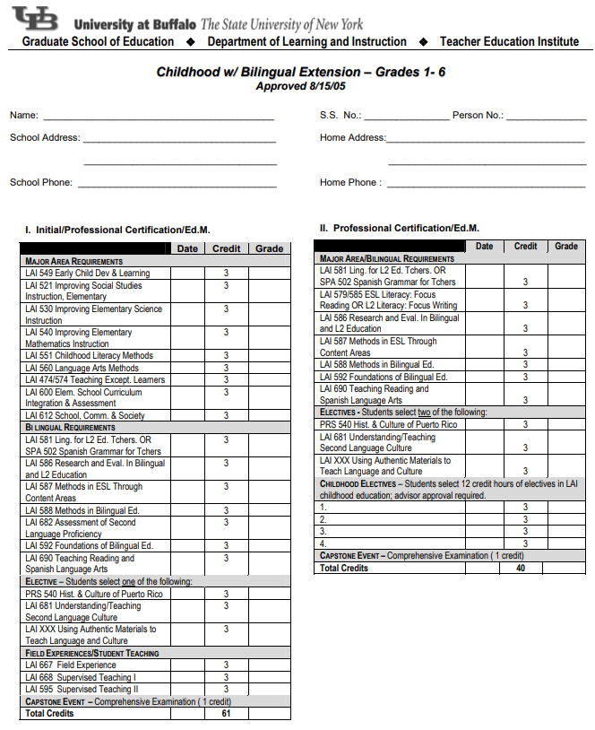
Early Childhood Education with Bilingual Extension*

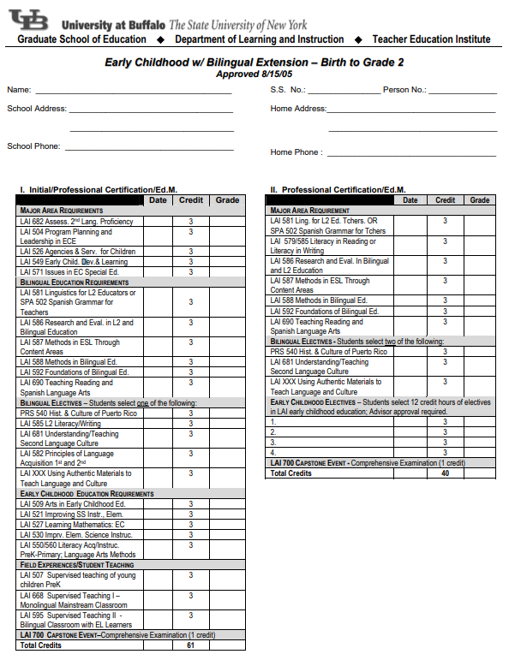
*Both tracks also include LAI 574: Teaching Exceptional Children as an elective.

Comprehensive Exam
You will take your comprehensive exam during your second or third semester of coursework. Consult with your advisor to learn more about this exam and how you can best prepare. Students answer one comprehensive exam using the Spanish language.
Research Opportunities & Internships
Students in the Bilingual Extension programs complete field experiences, which provides the opportunity to gain experience teaching using English and Spanish while also being supplied ample support and feedback.

All students in these programs develop the ability to read and understand research, and many courses include projects that engage students in exploring research methods that are most relevant to language teachers. Three specific courses (Foundations of Bilingual and L2 Education, Research and Evaluation in Bilingual and L2 Education, and ESL Content Methods) provide field experiences and require students to complete a field study in which students become familiar with observation methods, data collection procedures and data analysis.

Additional research opportunities available to the students include the possibility of working on a faculty research project. Speak with your advisor and professors to see if formal graduate assistantships on research projects or other forms of participation may be possible. In some cases, especially if you envision possible continuation of graduate study in a doctoral program, you might opt to pursue a master’s thesis project. In this case, you should consult with your advisor very early on in your program of study to plan for appropriate research methods courses and to set up a committee of faculty members that will read your thesis and supervise your thesis defense.

The Master’s (EdM) Degree in ESOL
with Initial/Professional Certification or Professional Certification Programs

General Introduction and Information
Our master's program in ESOL education is for you if you wish to obtain New York State initial/professional certification to teach grades K–12 bilingual and/or English language learners. This program is also for you if you have already obtained initial teacher certification before entering the program, but you aspire to complete both a master's degree in ESOL education and satisfy grades K–12 professional ESOL certification requirements. Our program focuses on teaching English as a new language to speakers of other languages in American educational systems: early childhood, childhood and secondary schools.
Why English for Speakers of Other Languages Education at UB?
The features of our program include:
- research and evaluation projects, including field experiences and projects in collaboration with local schools' bilingual and second language programs
- study of English language learners and bilingual education students
- study of foundation of bilingual, dual and second language education
- study of bilingualism and first and second language acquisition
- study of developmental readers, second language reading processes, and reading instruction at elementary grades; second language literacy; adolescent literacy practice; language, literacy and culture; children's and young adult literature; and classroom reading and second language assessment

Prerequisite
To be eligible for this program, you must have majored in or completed 30 credit hours in one of the following areas:

- English
- Languages other than English
- Linguistics
- Speech and Communication

Credit Hours & Master Coursework Requirements

Ed.M. Initial/Professional Certification

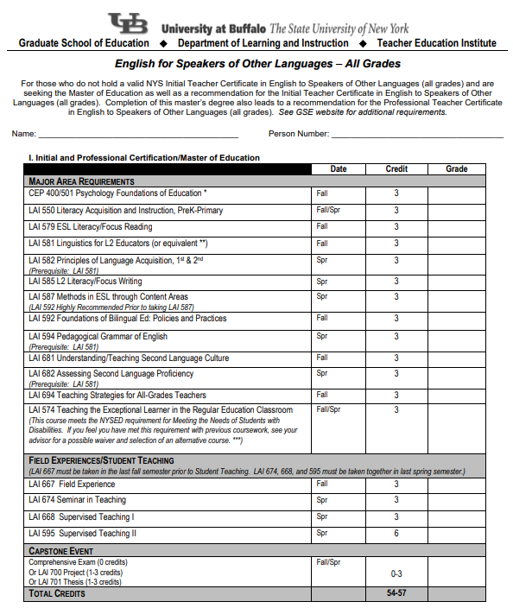

Comprehensive Exam
You will take your comprehensive exam during your second or third semester of coursework. Consult with your advisor to learn more about this exam and how you can best prepare. Students answer one comprehensive exam using the Spanish language.
Research Opportunities & Internships
Students in the ESOL programs complete field experiences, which provides the opportunity to gain experience teaching using English while also being supplied ample support and feedback.

All students in these programs develop the ability to read and understand research, and many courses include projects that engage students in exploring research methods that are most relevant to language teachers. Three specific courses (Foundations of Bilingual and L2 Education, Research and Evaluation in Bilingual and L2 Education, and ESL Content Methods) provide field experiences and require students to complete a field study in which students become familiar with observation methods, data collection procedures and data analysis.

Additional research opportunities available to the students include the possibility of working on a faculty research project. Speak with your advisor and professors to see if formal graduate assistantships on research projects or other forms of participation may be possible. In some cases, especially if you envision possible continuation of graduate study in a doctoral program, you might opt to pursue a master’s thesis project. In this case, you should consult with your advisor very early on in your program of study to plan for appropriate research methods courses and to set up a committee of faculty members that will read your thesis and supervise your thesis defense.

The Master’s (EdM) Degree in TESOL

General Introduction and Information

Our master's degree program in teaching English to speakers of other languages is for you if you want to (1) teach in college-level English as a second language (ESL) programs, (2) teach in adult-level ESL programs for immigrants and refugees in the United States, and (3) teach in all levels internationally. The EdM TESOL degree has been considered the terminal professional degree for those seeking opportunities to teach ESL/ENL (English as a new language) in national and international institutions of higher education.

As a student in this program you will:

- acquire a solid foundation in TESOL with coursework in methodology, second language acquisition, pedagogical grammar and a semester long practicum
- add breadth and depth to your preparation with courses in second language literacy, assessment, online pedagogical uses of technology and intercultural communication
- develop a practical approach, grounded by current theory and research, in the fields of applied linguistics, educational theory, best practices in pedagogy and second language acquisition
- have opportunities to interact with and learn from graduate students in many fields of education such as early childhood education and traditional teacher education specializations

Credit Hours & Master Coursework Requirements

Required Courses (15-18 Credits):
- LAI 581 Linguistics for L2 Educators
- LAI 591 TESOL Methods and Materials
- LAI 582 Principles Lang Acquisition, 1st & 2nd
- LAI 594 Pedagogical Grammar of English
- LAI 685 Academic Language Writing/Literacy
- LAI 691 TESOL Practicum

Students with adequate preparation in linguistics may waive LAI 581 Linguistics for L2 Educators, which will allow you to take a 3-hour graduate elective in lieu of this course. Consult with your advisor.

Academic Language Writing/Literacy is required for international students unless waived by your advisor.

Select at Least 3 Courses (9 Credits):
- LAI 681 Understanding & Teaching L2 Culture
- LAI 682 Assessing Second Lang. Proficiency
- LAI 579 ESL Literacy: Reading Focus
- LAI 585 L2 Literacy: Focus Writing

Other courses in the L2 area offered by L2 faculty (consult with your advisor)

Electives (6-9 Credits):
- Elective courses may be inside or outside the second language area of the Department of Learning and Instruction, including such areas as: anthropology, comparative education, educational psychology, foreign languages, historical/social/philosophical foundations of education, instructional communications, linguistics, reading, language arts or bilingual education.

Comprehensive Examination
You will take your comprehensive exam during your second or third semester of coursework. Consult with your advisor.

Research Opportunities & Internships
Students in the TESOL program complete a practicum, which provides the opportunity to gain experience teaching English while also being supplied ample support and feedback.

All students in the TESOL program develop the ability to read and understand research, and many courses include projects that engage students in exploring research methods that are most relevant to language teachers.

Additional research opportunities available to you as a student include the possibility of working on a faculty research project. Speak with your advisor and professors to see if formal graduate assistantships on research projects or other forms of participation may be possible. In some cases, especially if you envision possible continuation of graduate study in a doctoral program, you might opt to pursue a master’s thesis project. In this case, you should consult with your advisor very early on in your program of study to plan for appropriate research methods courses and to set up a committee of faculty members that will read your thesis and supervise your thesis defense.

The Advanced Certificate or Master’s (EdM) Degree in
Languages Other Than English
with Initial-only, Initial-Professional, or Professional certification
Chinese, French, Latin and Spanish

General Introduction and Information

Our advanced certificate and master's program in Languages Other Than English education are for you if you intend to teach world languages particularly in public schools. The coursework of our program includes current theories and their implications for teaching methods, materials and assessment.

The features of our program include:
- Affordability – low cost, 50% less than comparable universities
- Flexibility – online and on-campus (day and night) courses
- Professional engagement - opportunities to connect with and participate in local, regional and national organizations
- Quality – respected leaders in the learning and teaching of world languages
- Technology – use of the latest digital resources and tools

Prerequisite
To be eligible for this program, you must have majored in or completed 30 credit hours in the language (French, Spanish, Chinese or Latin/Classics) of the certification area.

Credit Hours & Master Coursework Requirements
Program coursework and requirements are different depending on the language in which you will be certified to teach and the type of certification you are pursuing. Be sure to consult with your advisor as you use the following program charts to help you plan and keep track of your coursework.

Advanced Cert., Ed.M. Initial/Professional Certification, & Ed.M. Professional in French, Latin, or Spanish

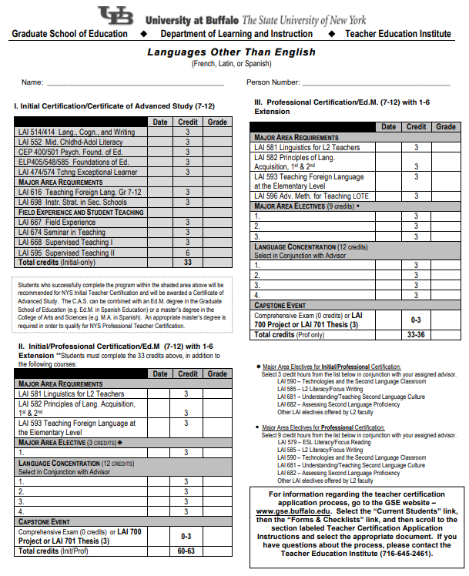

Advanced Certificate or Initial Certification in Chinese*

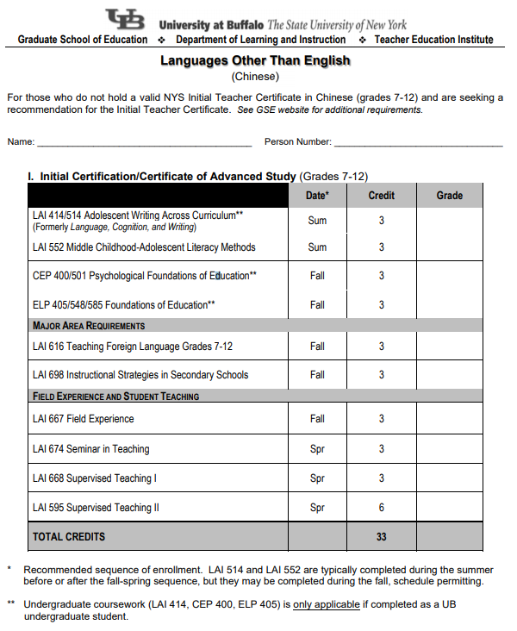

* LAI 574: Teaching Exceptional Children as an elective

Professional Certification (Ed.M.) in Chinese*

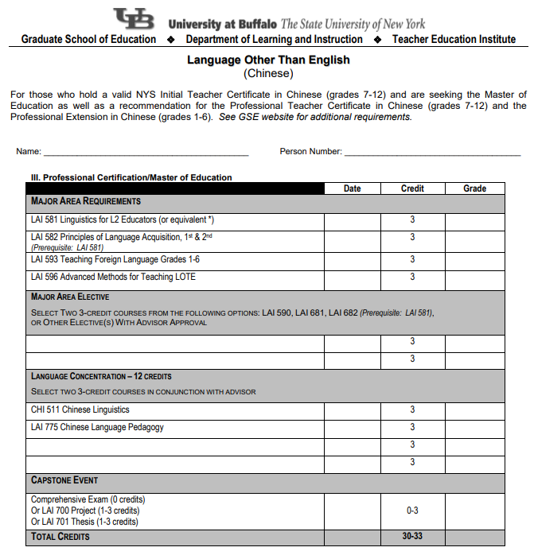

* LAI 574: Teaching Exceptional Children as an elective

Initial/Professional Certification (Ed.M) in Chinese*

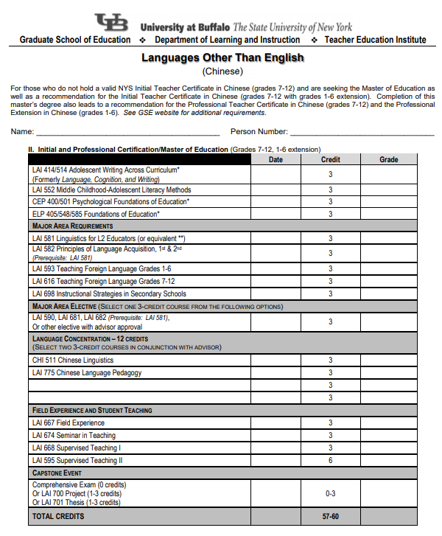

Comprehensive Exam
You will take your comprehensive exam in the last or second to last semester of coursework. Consult with your advisor to learn more about this exam and how you can best prepare.

Research Opportunities & Internships

Students in the LOTE programs that include initial certification will complete field experience and student teaching experiences that you can learn about more through GSE’s Teacher Education Institute.

Students in the LOTE programs that include only professional certification complete one course (LAI 593) in elementary school level world languages teaching methods, which includes a brief field experience. All graduates of LOTE programs that include professional certification are recommended for the grades 1-6 extension as a result of completing this course.

All students in the LOTE programs develop the ability to read and understand research, and many courses include projects that engage students in exploring research methods that are most relevant to language teachers.

Additional research opportunities available to you as a student include the possibility of working on a faculty research project. Speak with your advisor and professors to see if formal graduate assistantships on research projects or other forms of participation may be possible. In some cases, especially if you envision possible continuation of graduate study in a doctoral program, you might opt to pursue a master’s thesis project. In this case, you should consult with your advisor very early on in your program of study to plan for appropriate research methods courses and to set up a committee of faculty members that will read your thesis and supervise your thesis defense.

Certification Programs

Childhood with Bilingual Education Extension, (Initial/Professional and Professional)
Our master's program in childhood education with bilingual extension is for you if you wish to obtain New York State initial/professional certification to teach childhood (grades 1–6) students and/or bilingual and English language learners, grades 1–6. This program is also for you if you have already obtained initial teacher certification before entering the program, but you aspire to complete both a master's degree in childhood education with bilingual extension and satisfy grades 1–6 professional certification requirements.

Early Childhood with Bilingual Education Extension (Initial/Professional and Professional)
Our master's program in early childhood education prepares you to teach children from birth–grade 2. If you do not have an undergraduate degree in education, you can enroll in our initial/professional program. If you have completed an approved undergraduate major, our program enables you to pursue a master's degree and satisfy birth–grade 2 certification requirements.

English as a Second Language Certification (Grades 1-12)(Initial/Professional and Professional)

Our master's degree program in teaching English to speakers of other languages is for you if you want to (1) teach in college-level English as a second language (ESL) programs, (2) teach in adult-level ESL programs for immigrants and refugees in the United States, and (3) teach in all levels internationally. The EdM TESOL degree has been considered the terminal professional degree for those seeking opportunities to teach ESL/ENL (English as a new language) in national and international institutions of higher education.

Languages other than English (Chinese, French, Latin and Spanish)(Initial/Professional and Professional)

Our advanced certificate and master's program in Languages Other Than English education are for you if you intend to teach world languages particularly in public schools. The coursework of our program includes current theories and their implications for teaching methods, materials and assessment.

The Doctoral (PhD) Degree in Foreign and Second Language Education

General Information
Our doctoral program in foreign and second language education focuses on preparing you for research, teaching and administrative posts in colleges and universities, and for positions of educational leadership in the schools or in state education departments. The mission of our program is to foster the development of foreign/second/bilingual language education practitioners and researchers who can understand and analyze language teaching and learning, and language policy to improve language and content teaching and learning in diverse educational contexts.

Why Foreign and Second Language Education at UB?

The features of our program include:
- becoming familiar with groundbreaking inquiry processes and research methodologies
- carrying out principled, meaningful and rigorous research and applying it to real-world educational challenges
- collaborating with internationally recognized scholars who mentor students to engage in research studies
- developing an understanding of language theory and an ability to thoughtfully apply this theory
- engaging in scholarship that involves participation in the exchange of ideas and advancement of the field as a whole
- preparing scholars and educational leaders to pursue careers in academia, and occupy positions of leadership in American and global universities and colleges
Credit Hours & PhD Coursework Requirements

PhD in Foreign and Second Language Education requires 72 credit hours:
- Concentration – 24 credit hours
- Research – 28 credit hours (21 credits of courses, 6 hours of research component/practicum, 1 credit of research analysis exam)
- Dissertation – 10 credit hours
- Relevant master's degree courses – 10 credit hours

Guidelines for Dissertation

Introduction
- Graduate School of Education Dissertation Checklist and Timeline

Dissertation Committee
When completing the Doctoral Application to Candidacy, students should consult with their primary advisor to form a dissertation committee based on their interests.

- The chair of a Ph.D. or Ed.D. dissertation committee must be a member of the student’s department, must be a member of the UB Graduate School Faculty, and must NOT be of qualified rank. If special circumstances seem to require a chair of a Ph.D. or Ed.D. dissertation committee to be from outside of the student’s department but within GSE, then the appointment should be made with the advice and consent of the student’s department (i.e., designated departmental committee).
- The two additional required members of a Ph.D. or Ed.D. dissertation committee must hold the unqualified rank of assistant professor or above, or, if they are of qualified rank, they must be a member of the UB Graduate School Faculty.
- A person not meeting the above qualifications can be an additional (fourth) member of a Ph.D. or Ed.D. dissertation committee.

- Note: If an individual from outside the University at Buffalo faculty is proposed to serve on a dissertation committee, he/she must provide a curriculum vitae. The student and major advisor are asked to provide a statement affixed to this form as to why they believe that individual is more appropriate than a regularly appointed member of the University at Buffalo faculty.

Dissertation Proposal

Guidelines for Dissertation Proposal Abstracts
A dissertation proposal abstract (not over 200 words) should not only demonstrate appropriate form (grammar, spelling) but should also contain the following elements:
- A one- or two-sentence statement of the topic to be discussed or the problem to be investigated;
- An explanation of the purpose or importance of the proposed dissertation;
- A brief description of the information sources to be consulted (depending on the type of dissertation these may be: the subjects/participants, the field work context, published literature, written documents, etc.);
- A brief description of the proposed procedures for data collection and/or analysis of results (e.g., surveys, interventions, statistics, policy analysis, historical or philosophical treatments);
- A statement describing how the findings obtained or conclusions reached will be linked to a larger body of knowledge in the field.

Dissertation Defense
All doctoral candidates present a public defense of their dissertation findings. The findings are vetted by the dissertation committee.

Result of Dissertation Defense
Almost all dissertation defenses require further revision and refinement of the dissertation. This is the most common outcome. After defending the dissertation in a public forum, the dissertation committee convenes in a private session to discuss the outcome. The doctoral candidate is then invited in and results are shared. Students may fail a dissertation defense and be required to revise and defend their findings again, although this is a rare occurrence.

Dissertation Paperwork
Required paperwork for dissertation defense:
- M Form
- Petition to Change Expected Conferral Date (Only if necessary)

UB Guidelines and Requirements to Submit Dissertation
- Dissertation Electronic Submission

International Student Information
Questions and concerns related to International Student Services can be obtained through the International Student Services Office. The link for this resource is http://www.buffalo.edu/international-student-services.html

Online Education
Courses within this program are offered online and face to face.

Degree Conferral

Candidacy
Apply for Graduation via the HUB Student Center.

Notify the University of your expected Conferral (graduation) date via the HUB Student Center. The “apply for graduation” link is on the “My Academics” tab.

Note: Should you miss the deadline, you will need to apply for the next conferral (graduation) date AND register for at least one credit hour in the semester you will graduate (maintain continuous registration policy).

UB confers degrees three times a year:

Application Deadlines
Graduation Term | Application Deadline | Conferral Date
Fall | October 15 | February 1
Spring | February 22 | June 1
Summer | July 15 | September 1

Use this link for more information about degree conferral.
Commencement information can be found at this link.

Details regarding various tasks that relate to graduation can be found at the following links:

- Apply for Graduation: A Must Do, and Degree Checkout Status
- Double Degree Candidates (i.e. BS and BA, two degrees awarded at one time)
- Follow Up With Advisement
- Review Your Transcript(s)
- Confirm Your Grades
- Pay Outstanding Bills
- Verify Your Name and Address
- Sign Up For Your Commencement Ceremony
- Check-in with Career Services & Take the Undergraduate Senior Exit Survey

Campus Resources and Services
a. Student Advisement
Upon acceptance into a program, you will be assigned an adviser who will develop a tentative plan of study based on your career goals, experiences and needs. A student has the right to change advisers for any number of reasons including interest in another faculty member’s research, etc.

b. Office locations
The LAI Main Office is on the 5th Floor of Baldy Hall; the Teacher Education Institute is on the 3rd floor of Baldy Hall in room 375.

c. UB Libraries
There are multiple libraries available on campus for a complete listing please see the following link: https://library.buffalo.edu/.

However, two libraries will be of interest to music education students: The graduate library known as Lockwood Memorial Library and the Music Library in Baird Hall.

d. UB Information Technology
UB offers students a wide range of IT services. Complete information, including free software available to UB students, is found at the following link: http://www.buffalo.edu/ubit.html.

e. UB Student Services
For information regarding available student services, use the following link: https://1capen.buffalo.edu/.

University Policy and Procedures
For a complete list of University Policies and Procedures please see the following websites:
Student Code of Conduct: http://www.buffalo.edu/content/dam/www/studentlife/units/uls/student-conduct/ub-student-code-of-conduct.pdf
Information Technology Polices:
https://catalog.buffalo.edu/policies/information_technology%20policies.html
Academic Integrity:
https://catalog.buffalo.edu/policies/integrity.html
All policy and procedures for graduate study at UB can be found in the Graduate School Policy Library. By using this link you will be sure to find the most up to date information.

The LAI Department reserves the right to amend, alter, and update the policies, procedures, or other information provided in this handbook as needed. Changes, revisions, and amendments to the material in this handbook will be published on the LAI Department website and in future editions of the handbook.

